

**SQL Server In-Memory OLTP Internals Overview**

SQL Server Technical Article

**Summary:** In-Memory OLTP (project “Hekaton”) is a new database engine component, fully integrated into SQL Server. It is optimized for OLTP workloads accessing memory resident data. In-Memory OLTP allows OLTP workloads to achieve significant improvements in performance, and reduction in processing time. Tables can be declared as ‘memory optimized’ to enable In-Memory OLTP’s capabilities. Memory-optimized tables are fully transactional and can be accessed using Transact-SQL. Transact-SQL stored procedures can be compiled to machine code for further performance improvements on memory-optimized tables. The engine is designed for high concurrency and blocking is minimal.

**Writer:** Kalen Delaney

**Technical Reviewers:** Kevin Liu, Sunil Agarwal, Jos de Bruijn, Kevin Farlee, Mike Zwilling, Craig Freedman, Mike Weiner, Cristian Diaconu, Pooja Harjani, Paul Larson, David Schwartz, Darmadi Komo

**Published:** March 2014 (updated)

**Applies to:** SQL Server 2014

Copyright

This document is provided “as-is”. Information and views expressed in this document, including URL and other Internet Web site references, may change without notice. You bear the risk of using it.

This document does not provide you with any legal rights to any intellectual property in any Microsoft product. You may copy and use this document for your internal, reference purposes.

© 2014 Microsoft. All rights reserved.

Contents

Introduction 5

Design Considerations and Purpose 5

Terminology 6

Overview of Functionality 6

What’s Special about In-Memory OLTP? 7

Memory-optimized tables 7

Indexes on memory-optimized tables 8

Concurrency improvements 8

Natively Compiled Stored Procedures 9

Is In-Memory OLTP just an improved DBCC PINTABLE? 9

Offerings from competitors 9

Using In-Memory OLTP 10

Creating Databases 10

Creating Tables 11

Row and Index Storage 13

Rows 13

Row header 14

Payload area 15

Indexes On Memory-Optimized Tables 15

Hash Indexes 15

Memory-optimized nonclustered indexes 18

Data Operations 22

Isolation Levels Allowed with Memory-Optimized Tables 23

Deleting 24

Updating and Inserting 24

Reading 25

Validation 26

T-SQL Support 27

Garbage Collection of Rows in Memory 28

Transaction Isolation and Concurrency Management 29

Durability and Storage for Memory-optimized Tables 32

Transaction Logging 33

Checkpoint 36

Completing a Checkpoint 36

Merging of Checkpoint Files 37

Automatic Merge 37

Manual Merge sys.sp_xtp_merge_checkpoint_files 38

Storage Considerations for Checkpoint Files 38

Garbage Collection of Checkpoint Files 38

Recovery 39

Native Compilation of Tables and Stored Procedures 39

What is native compilation? 39

Maintenance of DLLs 40

Native compilation of tables 40

Native compilation of stored procedures 41

Compilation and Query Processing 41

SQL Server Feature Support 43

Manageability Experience 43

Metadata 43

Catalog Views 43

Dynamic Management Objects 44

XEvents 45

Performance Counters 45

Memory Usage Report 45

Memory Requirements 46

Managing Memory with the Resource Governor 47

Using the Analyze, Migrate and Report Toolset to Help with Migration 48

Summary 49

For more information: 49

# Introduction

SQL Server was originally designed at a time when it could be assumed that main memory was very expensive, so data needed to reside on disk except when it was actually needed for processing. This assumption is no longer valid as memory prices have dropped enormously over the last 30 years. At the same time, multi-core servers have become affordable, so that today one can buy a server with 32 cores and 1TB of memory for under $50K. Since many, if not most, of the OLTP databases in production can fit entirely in 1TB, we need to re-evaluate the benefit of storing data on disk and incurring the I/O expense when the data needs to be read into memory to be processed. In addition, OLTP databases also incur expenses when this data is updated and needs to be written back out to disk. Memory-optimized tables are stored completely differently than disk-based tables and these new data structures allow the data to be accessed and processed much more efficiently.

Because of this trend to much more available memory and many more cores, the SQL Server team at Microsoft began building a database engine optimized for large main memories and many-core CPUs. This paper gives a technical overview of this new database engine feature: In-Memory OLTP.

For more information about In-Memory OLTP, see [In-Memory OLTP (In-Memory Optimization)](http://msdn.microsoft.com/en-us/library/dn133186(v=sql.120).aspx) (http://msdn.microsoft.com/en-us/library/dn133186(v=sql.120).aspx).

# Design Considerations and Purpose

The move to produce a true main-memory database has been driven by three basic needs: 1) fitting most or all of data required by a workload into main-memory, 2) lower latency time for data operations, and 3) specialized database engines that target specific types of workloads need to be tuned just for those workloads. Moore’s law has impacted the cost of memory allowing for main memories to be large enough to satisfy (1) and to partially satisfy (2). (Larger memories reduce latency for reads, but don’t affect the latency required for writes to disk needed by traditional database systems). Other features of In-Memory OLTP allow for greatly improved latency for data modification operations. The need for specialized database engines is driven by the recognition that systems designed for a particular class of workload can frequently out-perform more general purpose systems by a factor of 10 or more. Most specialized systems, including those for CEP (complex event processing), DW/BI and OLTP, optimize data structures and algorithms by focusing on in-memory structures.

Microsoft’s reason for creating In-Memory OLTP comes mainly from this fact that main memory sizes are growing at a rapid rate and becoming less expensive. In addition, because of the near universality of 64 bit architectures and multicore processors, it is not unreasonable to think that most, if not all, OLTP databases or the entire performance sensitive working dataset could reside entirely in memory. Many of the largest financial, online retail and airline reservation systems fall between 500GB to 5TB with working sets that are significantly smaller. As of 2012, even a two socket server could hold 2TB of DRAM using 32GB DIMMS (such as IBM x3680 X5). Looking further ahead, it’s entirely possible that in a few years you’ll be able to build distributed DRAM based systems with capacities of 1-10 Petabytes at a cost less than $5/GB. It is also only a question of time before non-volatile RAM becomes viable.

If most or all of an application’s data is able to be entirely memory resident, the costing rules that the SQL Server optimizer has used since the very first version become almost completely obsolete, because the rules assume all pages accessed can potentially require a physical read from disk. If there is no reading from disk required, the optimizer can use a different costing algorithm. In addition, if there is no wait time required for disk reads, other wait statistics, such as waiting for locks to be released, waiting for latches to be available, or waiting for log writes to complete, can become disproportionately large. In-Memory OLTP addresses all these issues. In-Memory OLTP removes the issues of waiting for locks to be released, using a new type of multi-version optimistic concurrency control. It reduces the delays of waiting for log writes by generating far less log data and needing fewer log writes.

# Terminology

SQL Server 2014’s *In-Memory OLTP* feature refers to a suite of technologies for working with memory-optimized tables. The alternative to memory-optimized tables will be referred to as *disk-based tables*, which SQL Server has always provided. Terms to be used include:

* *Memory-optimized tables* refer to tables using the new data structures added as part of In-Memory OLTP, and will be described in detail in this paper.
* *Disk-based tables* refer to the alternative to memory-optimized tables, and use the data structures that SQL Server has always used, with pages of 8K that need to be read from and written to disk as a unit.
* *Natively compiled stored procedures* refer to an object type supported by In-Memory OLTP that is compiled to machine code and has the potential to increase performance even further than just using memory-optimized tables. The alternative is *interpreted Transact-SQL* stored procedures, which is what SQL Server has always used. Natively compiled stored procedures can only reference memory-optimized tables.
* *Cross-container transactions* refer to transactions that reference both memory-optimized tables and disk-based tables.
* *Interop* refers to interpreted Transact-SQL that references memory-optimized tables

# Overview of Functionality

During most of your data processing operations with In-Memory OLTP, you may be unaware that you are working with memory-optimized tables rather than disk-based tables. However, SQL Server is working with your data very differently if it is stored in memory-optimized tables. In this section, we’ll look at an overview of how In-Memory OLTP operations and data are handled differently than disk-based operations and data in SQL Server. We’ll also briefly mention some of the memory optimized database solutions from competitors and point out how SQL Server In-Memory OLTP is different from them.

# What’s Special about In-Memory OLTP?

Although In-Memory OLTP is integrated with the SQL Server relational engine, and can be accessed using the same interfaces transparently, its internal behavior and capabilities are very different. Figure 1 gives an overview of the SQL Server engine with the In-Memory OLTP components.

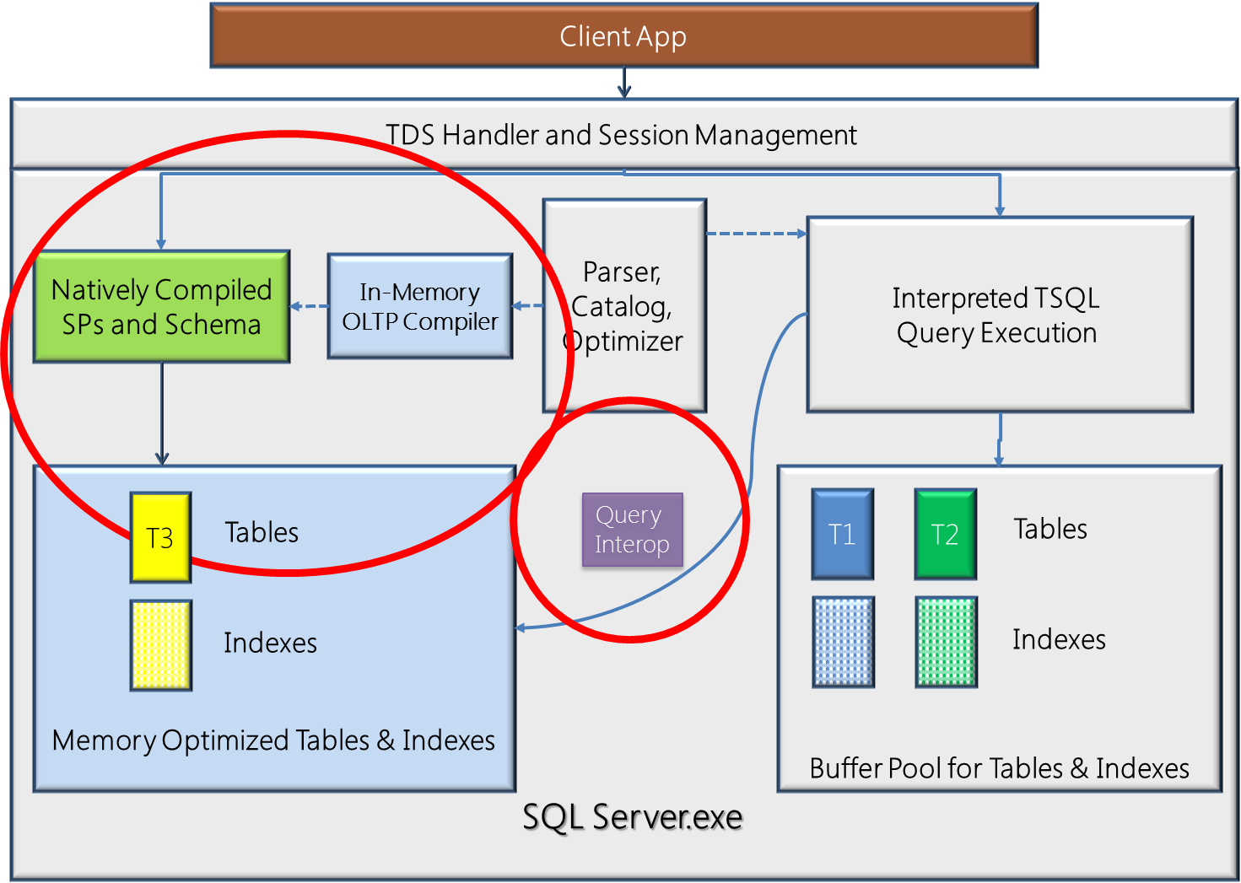

Figure 1The SQL Server engine including the In-Memory OLTP component

Notice that the client application connects to the TDS Handler the same way for memory-optimized tables or disk-based tables, whether it will be calling natively compiled stored procedures or interpreted Transact-SQL. You can see that interpreted Transact-SQL can access memory-optimized tables using the interop capabilities, but that natively compiled stored procedures can only access memory-optimized tables.

## Memory-optimized tables

The most important difference between memory-optimized tables and disk-based tables is that pages do not need to be read into cache from disk when the memory-optimized tables are accessed. All the data is stored in memory, all the time. A set of checkpoint files (data and delta file pairs), which are only used for recovery purposes, is created on files residing in memory-optimized filegroup that keep track of the changes to the data, and the checkpoint files are append-only.

Operations on memory-optimized tables use the same transaction log that is used for operations on disk-based tables, and as always, the transaction log is stored on disk. In case of a system crash or server shutdown, the rows of data in the memory-optimized tables can be recreated from the checkpoint files and the transaction log.

In-Memory OLTP does provide the option to create a table that is non-durable and not logged using an option called SCHEMA_ONLY. As the option indicates, the table schema will be durable, even though the data is not. These tables do not require any IO operations during transaction processing, but the data is only available in memory while SQL Server is running. In the event of a SQL Server shutdown or an AlwaysOn Availability Group failover, the data in these tables is lost. The tables will be recreated when the database they belong to is recovered, but there will be no data in the tables. These tables could be useful, for example, as staging tables in ETL scenarios or for storing Web server session state. Although the data is not durable, operations on these tables meet all the other transactional requirements; they are atomic, isolated, and consistent. We’ll see the syntax for creating a non-durable table in the section on Creating Tables.

## Indexes on memory-optimized tables

Indexes on memory-optimized tables are not stored as traditional B-trees. Memory-optimized tables support nonclustered hash indexes, stored as hash tables with linked lists connecting all the rows that hash to the same value and memory-optimized nonclustered indexes, which are stored using special Bw-trees. While nonclustered hash indexes are optimal for point lookups, memory-optimized nonclustered indexes provide support for retrieving ranges of values, ordering of rows and optimize the performance of queries that use inequality predicates.

Every memory-optimized table must have at least one index, because it is the indexes that combine all the rows into a single table. Memory-optimized tables are never stored as unorganized sets of rows, like a disk-based table heap is stored.

Indexes are never stored on disk, and are not reflected in the on-disk checkpoint files and operations on indexes are never logged. The indexes are maintained automatically during all modification operations on memory-optimized tables, just like b-tree indexes on disk-based tables, but in case of a SQL Server restart, the indexes on the memory-optimized tables are rebuilt as the data is streamed into memory.

## Concurrency improvements

When accessing memory-optimized tables, SQL Server implements an optimistic multi-version concurrency control. Although SQL Server has previously been described as supporting optimistic concurrency control with the snapshot-based isolation levels introduced in SQL Server 2005, these so-called optimistic methods do acquire locks during data modification operations. For memory-optimized tables, there are no locks acquired, and thus no waiting because of blocking.

Note that this does not mean that there is no possibility of waiting when using memory-optimized tables. There are other wait types, such as waiting for a log write to complete at the end of a transaction. However, logging when making changes to memory-optimized tables is much more efficient than logging for disk-based tables, so the wait times will be much shorter. And there never will be any waits for reading data from disk, and no waits for locks on data rows.

## Natively Compiled Stored Procedures

The best execution performance is obtained when using natively compiled stored procedures with memory-optimized tables. However, there are limitations on the Transact-SQL language constructs that are allowed inside a natively compiled stored procedure, compared to the rich feature set available with interpreted code. In addition, natively compiled stored procedures can only access memory-optimized tables and cannot reference disk-based tables.

## Is In-Memory OLTP just an improved DBCC PINTABLE?

DBCC PINTABLE was a feature available in older versions of SQL Server that would not remove any data pages from a “pinned” table from memory, once those pages were read from disk. The pages did need to be read in initially, so there was always a cost for page reads the first time such a table was accessed. These pinned tables were no different than any other disk-based tables. They required the same amount of locking, latching and logging and they used the same index structures, which also required locking and logging. In-Memory OLTP memory-optimized tables are completely different than SQL Server disk-based tables, they use different data and index structures, no locking is used and logging changes to these memory-optimized tables is much more efficient that logging changes to disk-based tables.

## Offerings from competitors

For processing OLTP data, there are two types of specialized engines.  The first are main-memory databases.  Oracle has TimesTen, IBM has SolidDB and there are many others that primarily target the embedded DB space.  The second are applications caches or key-value stores (for example, Velocity – App Fabric Cache and Gigaspaces) that leverage app and middle-tier memory to offload work from the database system.  These caches continue to get more sophisticated and acquire database capabilities,such as transactions, range indexing, and query capabilities (Gigaspaces already has these for example).  At the same time, database systems are acquiring cache capabilities like high-performance hash indexes and scale across a cluster of machines (VoltDB is an example).  The In-Memory OLTP engine is meant to offer the best of both of these types of engines. One way to think of In-Memory OLTP is that it has the performance of a cache and the capability of a database. It supports storing your tables and indexes in memory, so you can create an entire database to be a complete in-memory system. It also offers high performance indexes and logging as well as other features to significantly improve query execution performance.

SQL Server In-Memory OLTP offers the following features that few (or any) of the competitions’ products provide:

* Integration between memory-optimized tables and disk-based tables so that the transition to a memory resident database can be made gradually, creating only your most critical tables and stored procedure as memory-optimized objects.
* Natively compiled stored procedures to improve execution time for basic data manipulation operations by orders of magnitude
* Both memory-optimized nonclustered hash and memory-optimized nonclustered indexes specifically optimized for main memory access
* No storage of data on pages, removing the need for page latches.
* True multi-version optimistic concurrency control with no locking or latching for any operations

The most notable difference in design of SQL Server In-Memory OLTP from competitors’ products is the “interop” integration. In a typical high end OLTP workload, the performance bottlenecks are concentrated in specific areas, such as a small set of tables and stored procedures. It would be costly and inefficient to force the whole database to be resident in memory. But to date, the other main competitive products require such an approach. In SQL Server’s case, the high performance and high contention area can be migrated to In-Memory OLTP, then the operations (stored procedures) on those memory-optimized tables can be natively compiled to achieve maximum business processing performance.

One other key In-memory OLTP improvement is to remove the page construct for memory optimized tables. This fundamentally changes the data operation algorithm from being disk optimized to being memory and cache optimized. As mentioned earlier, one of the confusions about In-Memory OLTP is that it’s simply “DBCC PINTABLE” as the tables are locked in the bufferpool. However, a lot of the competitors do still have the page constructs even while the pages are forced to stay in memory. For example SAP HANA still uses 16KB pages for its in-memory row-store, which would inherently suffer from page latch contention in a high performance environment.

# Using In-Memory OLTP

The In-Memory OLTP engine has been available as part of SQL Server 2014 since the June 2013 CTPs. Installation of In-Memory OLTP is part of the SQL Server setup application. The In-Memory OLTP components can only be installed with a 64-bit edition of SQL Server 2014, and not available at all with a 32-bit edition.

## Creating Databases

Any database that will contain memory-optimized tables must have a MEMORY_OPTIMIZED_DATA filegroup. This filegroup is used for storing the checkpoint files needed by SQL Server to recover the memory-optimized tables, and although the syntax for creating the filegroup is almost the same as for creating a regular filestream filegroup, it must also specify the option CONTAINS MEMORY_OPTIMIZED_DATA. Here is an example of a CREATE DATABASE statement for a database that can support memory-optimized tables:

CREATE DATABASE HKDB

ON

PRIMARY(NAME = [HKDB_data],

FILENAME = 'Q:\data\HKDB_data.mdf', size=500MB),

FILEGROUP [SampleDB_mod_fg] CONTAINS MEMORY_OPTIMIZED_DATA

(NAME = [HKDB_mod_dir],

FILENAME = 'R:\data\HKDB_mod_dir'),

(NAME = [HKDB_mod_dir],

FILENAME = 'S:\data\HKDB_mod_dir')

LOG ON (name = [SampleDB_log], Filename='L:\log\HKDB_log.ldf', size=500MB)

COLLATE Latin1_General_100_BIN2;

Note that the above code example creates files on three different drives (Q:, R: and S:) so if you would like to run this code, you might need to edit the path names to match your system. The names of the files on R: and S: are identical, so if you create all these files on the same drive you’ll need to differentiate the two file names.

Also notice a binary collation was specified. At this time, any indexes on memory-optimized tables can only be on columns using a Windows (non-SQL) BIN2 collation and natively compiled procedures only support comparisons, sorting, and grouping on those same collations. It can be specified (as done in the CREATE DATABASE statement above) with a default binary collation for the entire database, or you can specify the collation for any character data in the CREATE TABLE statement. (You can also specify collation in a query, for any comparison, sorting or grouping operation.)

It is also possible to add a MEMORY_OPTIMIZED_DATA filegroup to an existing database, and then files can be added to that filegroup. For example:

ALTER DATABASE AdventureWorks2012   
 ADD FILEGROUP hk_mod CONTAINS MEMORY_OPTIMIZED_DATA;

GO

ALTER DATABASE AdventureWorks2012   
 ADD FILE (NAME='hk_mod', FILENAME='c:\data\hk_mod')

TO FILEGROUP hk_mod;

GO

## Creating Tables

The syntax for creating memory-optimized tables is almost identical to the syntax for creating disk-based tables, with a few restrictions, as well as a few required extensions. Specifying that the table is a memory-optimized table is done using the MEMORY_OPTIMIZED = ON clause. A memory-optimized table can only have columns of these supported datatypes:

* bit
* All integer types: tinyint, smallint, int, bigint
* All money types: money, smallmoney
* All floating types: float, real
* date/time types: datetime, smalldatetime, datetime2, date, time
* numeric and decimal types
* All non-LOB string types: char(n), varchar(n), nchar(n), nvarchar(n), sysname
* Non-LOB binary types: binary(n), varbinary(n)
* Uniqueidentifier

Note that none of the LOB data types are allowed; there can be no columns of type XML, CLR or the *max* data types, and all row lengths are limited to 8060 bytes with no off-row data. In fact, the 8060 byte limit is enforced at table-creation time, so unlike a disk-based table, a memory-optimized tables with two varchar(5000) columns could not be created.

A memory-optimized table can be defined with one of two DURABILITY values: SCHEMA_AND_DATA or SCHEMA_ONLY with the former being the default. A memory-optimized table defined with DURABILITY=SCHEMA_ONLY, which means that changes to the table’s data are not logged and the data in the table is not persisted on disk. However, the schema is persisted as part of the database metadata, so the empty table will be available after the database is recovered during a SQL Server restart.

As mentioned earlier, a memory-optimized table must always have at least one index but this requirement could be satisfied with the index created automatically to support a primary key constraint. All tables except for those created with the SCHEMA_ONLY option must have a declared primary key. At least one index must be declared to support a PRIMARY KEY constraint. The following example shows a PRIMARY KEY index created as a HASH index, for which a bucket count must also be specified. A few guidelines for choosing a value for the bucket count will be mentioned when discussing details of hash index storage.

Single-column indexes may be created in line with the column definition in the CREATE TABLE statement, as shown below. ). The BUCKET_COUNT attribute will be discussed in the section on Hash Indexes.

CREATE TABLE T1

(

[Name] varchar(32) not null PRIMARY KEY NONCLUSTERED HASH WITH (BUCKET_COUNT = 100000),

[City] varchar(32) null,

[State_Province] varchar(32) null,

[LastModified] datetime not null,

) WITH (MEMORY_OPTIMIZED = ON, DURABILITY = SCHEMA_AND_DATA);

Alternatively, composite indexes may be created after all the columns have been defined, as in the example below. The example below adds a nonclustered index to the table definition above. Notice the difference in the specification for the two types of indexes is that one uses the keyword HASH, and the other doesn’t. Both types of indexes are specified as NONCLUSTERED, however HASH and a bucket count are the delineators between the two index definitions.

CREATE TABLE T2

(

[Name] varchar(32) not null PRIMARY KEY NONCLUSTERED HASH WITH (BUCKET_COUNT = 100000),

[City] varchar(32) null,

[State_Province] varchar(32) null,

[LastModified] datetime not null,

INDEX T1_ndx_c2c3 NONCLUSTERED ([City],[State_Province])

) WITH (MEMORY_OPTIMIZED = ON, DURABILITY = SCHEMA_AND_DATA);

When a memory-optimized table is created, the In-Memory OLTP engine will generate and compile DML routines just for accessing that table, and load the routines as DLLs. SQL Server itself does not perform the actual data manipulation (record cracking) on memory-optimized tables, instead it calls the appropriate DLL for the required operation when a memory-optimized table is accessed.

There are only a few limitations when creating memory-optimized tables, in addition to the data type limitations already listed.

* No DML triggers
* No FOREIGN KEY or CHECK constraints
* No UNIQUE indexes other than for the PRIMARY KEY
* A maximum of 8 indexes, including the index supporting the PRIMARY KEY

In addition, no schema changes are allowed once a table is created. Instead of using ALTER TABLE, you will need to drop and recreate the table. In addition, there are no specific index DDL commands (i.e. CREATE INDEX, ALTER INDEX, DROP INDEX). Indexes are always created at as part of the table creation.

# Row and Index Storage

In-Memory OLTP memory-optimized tables and their indexes are stored very differently than disk-based tables. Memory-optimized tables are not stored on pages like disk-based tables, nor is space allocated from extents, and this is due to the design principle of optimizing for byte-addressable memory instead of block-addressable disk.

## Rows

Rows are allocated from structures called heaps, which are different than the type of heaps SQL Server has supported for disk-based tables. Rows for a single table are not necessarily stored near other rows from the same table and the only way SQL Server knows what rows belong to the same table is because they are all connected using the tables’ indexes. This is why memory-optimized tables have the requirement that there must be at least one index created on them. It is the index that provides structure for the tables.

The rows themselves have a structure very different than the row structures used for disk-based tables. Each row consists of a header and a payload containing the row attributes. Figure 2 shows this structure, as well as expanding on the content of the header area.

Row header

Payload

Begin Ts

End Ts

StmtId

IdxLinkCount

8 bytes

8 bytes

4 bytes

2 bytes

8 bytes * (Number of indexes)

Figure 2 The structure of a row in a memory-optimized table

### Row header

The header contains two 8-byte fields holding In-Memory OLTP timestamps: a Begin-Ts and an End-Ts. Every database that supports memory-optimized tables manages two internal counters that are used to generate these timestamps.

* The Transaction-ID counter is a global, unique value that is reset when the SQL Server instance is restarted. It is incremented every time a new transaction starts.
* The Global Transaction Timestamp is also global and unique, but is not reset on a restart. This value is incremented each time a transaction ends and begins validation processing. The new value is then the timestamp for the current transaction. The Global Transaction Timestamp value is initialized during recovery with the highest transaction timestamp found among the recovered records. (We’ll see more about recovery later in this paper.)

The value of Begin-Ts is the timestamp of the transaction that inserted the row, and the End-Ts value is the timestamp for the transaction that deleted the row. A special value (referred to as ‘infinity’) is used as the End-Ts value for rows that have not been deleted. However, when a row is first inserted, before the insert transaction is completed, the transaction’s timestamp is not known so the global Transaction_ID value is used for Begin-Ts until the transaction commits. Similarly, for a delete operation, the transaction timestamp is not known, so the End-Ts value for the deleted rows uses the global Transaction_ID value, which is replaced once the real Transaction Timestamp is known. As we’ll see when discussing data operations, the Begin-Ts and End-Ts values determine which other transactions will be able to see this row.

The header also contains a four-byte statement ID value. Every statement within a transaction has a unique *StmtId* value, and when a row is created it stores the *StmtId* for the statement that created the row. If the same row is then accessed again by the same statement, it can be skipped.

Finally, the header contains a two-byte value (*idxLinkCount*) which is really a reference count indicating how many indexes reference this row. Following the *idxLinkCount* value is a set of index pointers, which will be described in the next section. The number of pointers is equal to the number of indexes. The reference value of 1 that a row starts with is needed so the row can be referenced by the garbage collection (GC) mechanism even if the row is no longer connected to any indexes. The GC is considered the ‘owner’ of the initial reference.

As mentioned, there is a pointer for each index on the table, and it is these pointers plus the index data structures that connect the rows together. There are no other structures for combining rows into a table other than to link them together with the index pointers. This creates the requirement that all memory-optimized tables must have at least one index on them. Also, since the number of pointers is part of the row structure, and rows are never modified, all indexes must be defined at the time your memory-optimized table is created.

### Payload area

The payload is the row itself, containing the key columns plus all the other columns in the row. (So this means that all indexes on a memory-optimized table are actually covering indexes.) The payload format can vary depending on the table. As mentioned earlier in the section on creating tables, the In-Memory OLTP compiler generates the DLLs for table operations, and as long as it knows the payload format used when inserting rows into a table, it can also generate the appropriate commands for all row operations.

## Indexes On Memory-Optimized Tables

All memory-optimized tables must have at least one index, because it is the indexes that connect the rows together. As mentioned earlier, data rows are not stored on pages, so there is no collection of pages or extents, no partitions or allocation units that can be referenced to get all the pages for a table. There is some concept of *index* pages for one of the types of indexes, but they are stored differently than indexes for disk-based tables.

In-Memory OLTP indexes, and changes made to them during data manipulation, are never written to disk. Only the data rows, and changes to the data, are written to the transaction log. All indexes on memory-optimized tables are created based on the index definitions during database recovery. We’ll cover details of in the Checkpoint and Recovery section below.

### Hash Indexes

A hash index consists of an array of pointers, and each element of the array is called a hash bucket. The index key column in each row has a hash function applied to it, and the result of the function determines which bucket is used for that row. All key values that hash to the same value (have the same result from the hash function) are accessed from the same pointer in the hash index and are linked together in a chain. When a row is added to the table, the hash function is applied to the index key value in the row. If there is duplication of key values, the duplicates will always generate the same function result and thus will always be in the same chain.

Figure 3 shows one row in a hash index on a *name* column. For this example, assume there is a very simple hash function that results in a value equal to the length of the string in the index key column. The first value of ‘Jane’ will then hash to 4, which is the first bucket in the hash index so far. (Note that the real hash function is much more random and unpredictable, but I am using the length example to make it easier to illustrate.) You can see the pointer from the 4 entry in the hash table to the row with Jane. That row doesn’t point to any other rows, so the index pointer in the record is NULL.

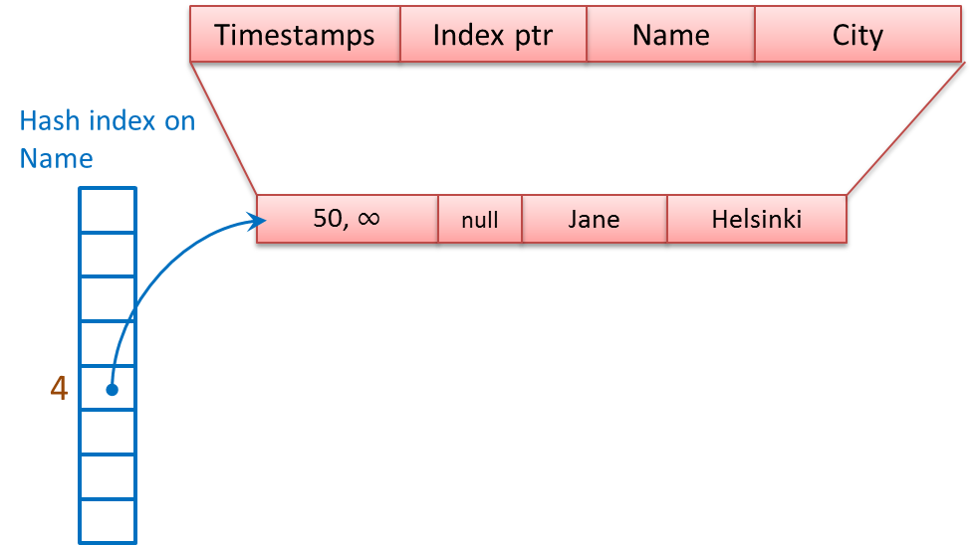

Figure 3 A hash index with a single row

In Figure 4, a row with a *name* value of Greg has been added to the table. Since we’ll assume that Greg also maps to 4, it hashes to the same bucket as Jane, and the row is linked into the same chain as the row for Jane. The Greg row has a pointer to the Jane row.

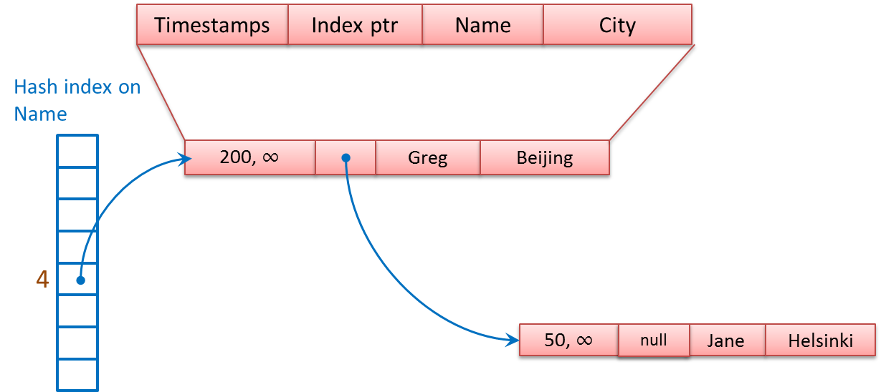

Figure 4 A hash index with two rows

A second hash index included in the table definition on the *City* column creates a second pointer field. Each row in the table now has two pointers pointing to it, and the ability to point to two more rows, one for each index. The first pointer in each row points to the next value in the chain for the *Name* index; the second pointer points to the next value in the chain for the *City* index. Figure 5 shows the same hash index on *Name*, this time with three rows that hash to 4, and two rows that hash to 5, which uses the second bucket in the *Name* index. The second index on the *City* column uses three buckets. The bucket for 6 has three values in the chain, the bucket for 7 has one value in the chain, and the bucket for 8 also has one value.

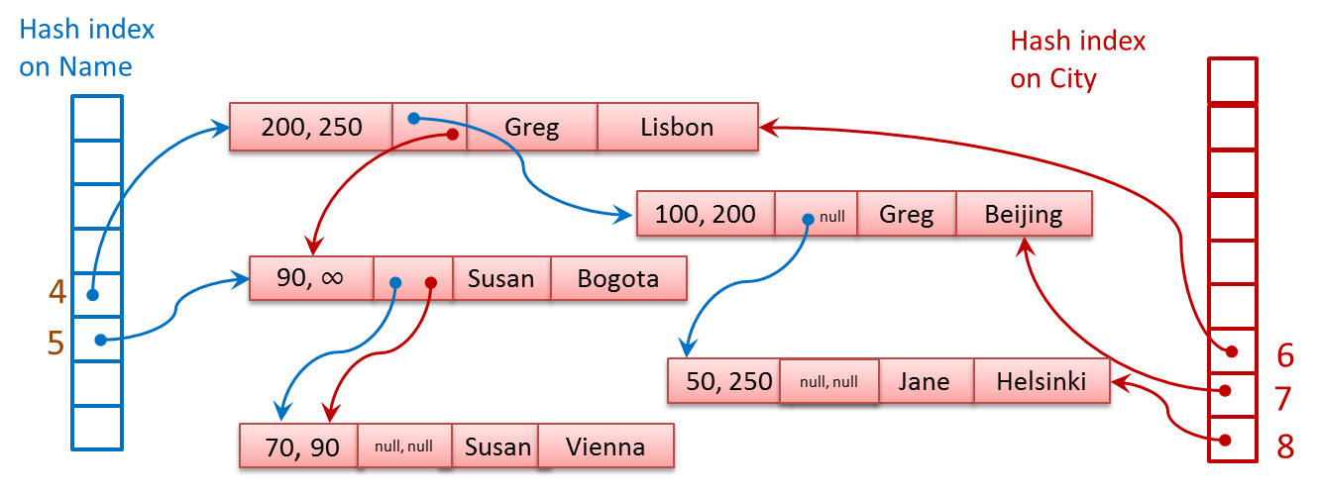

Figure 5 Two hash indexes on the same table

When a hash index is created, you must specify a number of buckets, as shown in the CREATE TABLE example above. It is recommended that you choose a number of buckets equal to or greater than the expected cardinality (the number of unique values) of the index key column so that there will be a greater likelihood that each bucket will only have rows with a single value in its chain. Be careful not to choose a number that is too big however, because each bucket uses memory. The number you supply is rounded up to the next power of two, so a value of 50,000 will be rounded up to 65,536. Having extra buckets will not improve performance but will simply waste memory and possible reduce the performance of scans which will have to check each bucket for rows.

When deciding to build a hash index, keep in mind that the hash function actually used is based on ALL the key columns. This means that if you have a hash index on the columns: *lastname, firstname* in an *employees* table, a row with the values “Harrison” and “Josh” will probably hash to a different bucket than a row with the values “Harrison” and “John”. A query that just supplies a *lastname* value, or one with an inexact *firstname* value (such as “Jo%”) will not be able to use the index at all.

### Memory-optimized nonclustered indexes

If you have no idea of the number of buckets you’ll need for a particular column, or if you know you’ll be searching your data based on a range of values, you should consider creating a memory-optimized nonclustered index instead of a hash index. These indexes are implemented using a new data structure called a Bw-tree, originally envisioned and described by Microsoft Research in 2011. The memory-optimized nonclustered index is a lock- and latch-free variation of a B-tree.

The general structure of this nonclustered index is similar to SQL Server’s regular B-trees, except that the index pages are not a fixed size, and once they are built they are unchangeable. Like a regular B-tree page, each index page contains a set of ordered key values, and for each value there is a corresponding pointer. At the upper levels of the index, on what are called the *internal pages*, the pointers point to an index page at the next level of the tree, and at the leaf level, the pointers point to a data row. Just like for In-Memory OLTP hash indexes, multiple data rows can be linked together. In the case of nonclustered indexes, rows that have the same value for the index key will be linked.

One big difference between the memory-optimized nonclustered index and SQL Server’s B-trees is that a page pointer is a logical page ID (PID), instead of a physical page number. The PID indicates a position in a mapping table, which connects each PID with a physical memory address. Index pages are never updated; instead, they are replaced with a new page and the mapping table is updated so that the same PID indicates a new physical memory address.

Figure 6 shows the general structure of a memory-optimized nonclustered index, plus the Page Mapping Table.

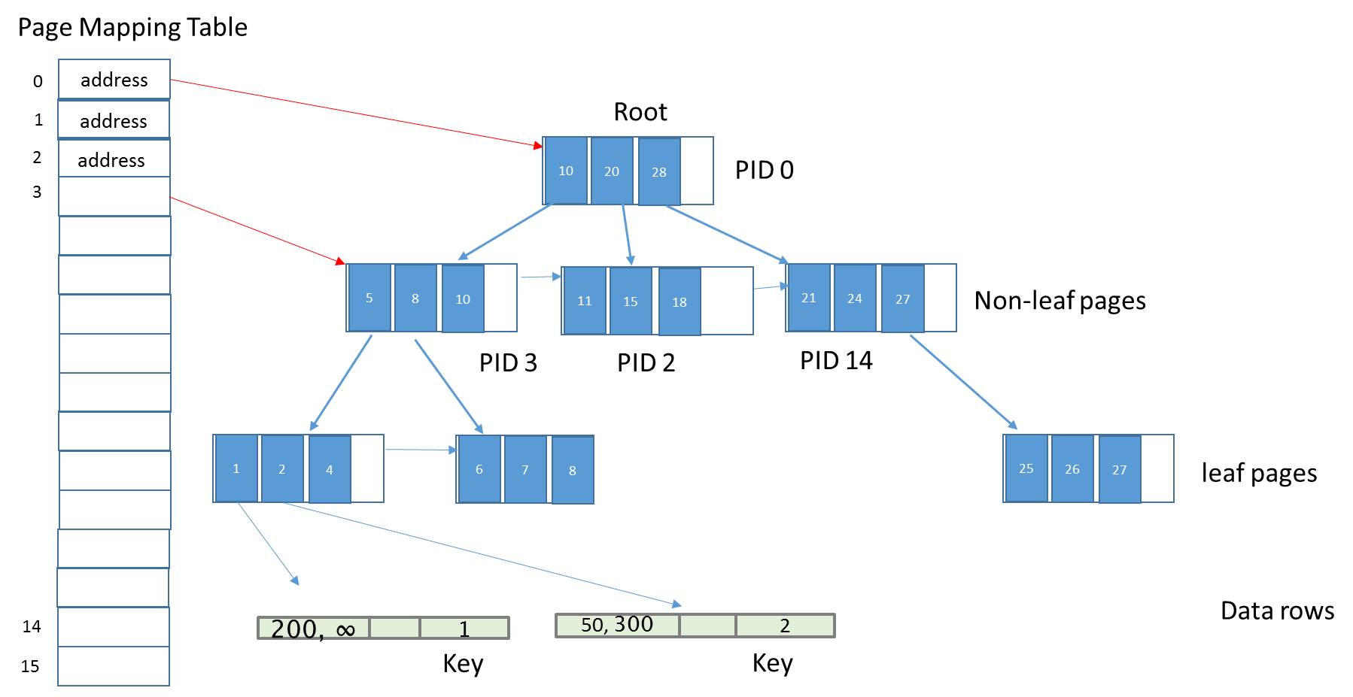

Figure 6 The general structure of a memory-optimized nonclustered index

Not all the PID values are indicated in Figure 6, and the Mapping Table does not show all the PID values that are in use. The index pages are showing the key values that the index references. Each index row in the internal index pages contains a key value (shown) and a PID of a page at the next level down. The key value is the highest value possible on the page referenced. (Note this is different than a regular B-Tree index, for which the index rows stores the **minimum** value on the page at the next level down.)

The leaf level index pages also contain key values, but instead of a PID, they contain an actual memory address of a data row, which could be the first in a chain of data rows, all with the same key value.

Another big difference between memory-optimized nonclustered indexes and SQL Server’s B-trees is that at the leaf level, data changes are kept track of using a set of delta values. The leaf pages themselves are not replaced for every change. Each update to a page, which can be an insert or delete of a key value on that page, produces a page containing a delta record indicating the change that was made. An update is represented by two new delta records, one for the delete of the original value, and one for the insert of the new value. When each delta record is added, the mapping table is updated with the physical address of the page containing the newly added delta record. Figure 7 illustrates this behavior. The mapping table is showing only a single page with logical address P. The physical address in the mapping table originally was the memory address of the corresponding leaf level index page, shown as Page P. After a new row with index key value 50 (which we’ll assume did not already occur in the table’s data) is added to the table, In-Memory OLTP adds the delta record to Page P, indicating the insert of the new key, and the physical address of page P is updated to indicate the address of the first delta record page. Assume then that the only row with index key value 48 is deleted from the table. In-Memory OLTP must then remove the index row with key 48, so another delta record is created, and the physical address for page P is updated once again.

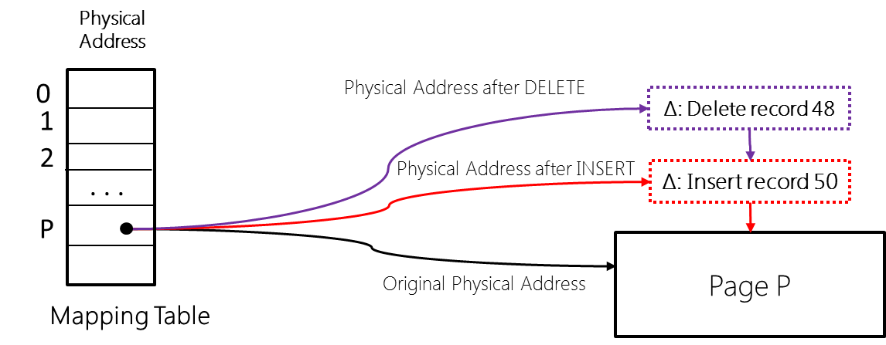

Figure 7 Delta records linked to a leaf level index page

#### Index page structures

In-Memory OLTP nonclustered index pages are not a fixed size as they are for indexes on disk-based tables, although the maximum index page size is still 8 KB.

Memory-optimized nonclustered index pages all have a header area which contains the following information:

* PID - the pointer into the mapping table
* Page Type - leaf, internal, delta or special
* Right PID - the PID of the page to the right of the current page
* Height – the vertical distance from the current page to the leaf
* Page statistics – the count of delta records plus the count of records on the page
* Max Key – the upper limit of values on the page

In addition, both leaf and internal pages contains two or three fixed length arrays:

* Values – this is really a pointer array. Each entry in the array is 8 bytes long. For internal pages the entry contains PID of a page at the next level and for a leaf page, the entry contains the memory address for the first row in a chain of rows having equal key values. (Note that technically, the PID could be stored in 4 bytes, but to allow the same values structure to be used for all index pages, the array allows 8 bytes per entry.)
* Offsets – this array exists only for pages of indexes with variable length keys. Each entry is 2 bytes and contains the offset where the corresponding key starts in the key array on the page.
* Keys – this is the array of key values. If the current page is an internal page, the key represents the first value on the page referenced by the PID. If the current page is a leaf page, the key is the value in the chain of rows.

The smallest pages are typically the delta pages, which have a header which contains most of the same information as in an internal or leaf page. However delta page headers don’t have the arrays described for leaf or internal pages. A delta page only contains an operation code (insert or delete) and a value, which is the memory address of the first row in a chain of records. Finally, the delta page will also contain the key value for the current delta operation. In effect you can think of a delta page as being a mini-index page holding a single element whereas the regular index pages store an array of N elements.

#### Nonclustered internal reorganization operations

There are three different operations that can be required for managing the structure of this index: consolidation, split and merge. For all of these operations, no changes are made to existing index pages. Changes may be made to the mapping table to update the physical address corresponding to a PID value. If an index page needs to add a new row (or have a row removed) a whole new page is created and the PID values are updated in the Mapping Table.

#### Consolidation of delta records

A long chain of delta records can eventually degrade search performance, if SQL Server has to consider the changes in the delta records along with the contents of the index pages when it’s searching through an index. If In-Memory OLTP attempts to add a new delta record to a chain that already has 16 elements, the changes in the delta records will be consolidated into the referenced index page, and the page will then be rebuilt, including the changes indicated by the new delta record that triggered the consolidation. The newly rebuilt page will have the same PID but a new memory address. The old pages (index page plus delta pages) will be marked for garbage collection.

#### Splitting of a full index page

An index page grows on as-needed basis starting from storing a single row to storing a maximum of 8K bytes. Once the index page grows to 8K bytes, a new insert of a single row will cause the index page to split. For an internal page, this means when there is no more room to add another key value and pointer, and for a leaf page, it means that the row would be too big to fit on the page once all the delta records are incorporated. The statistics information in the page header for a leaf page keeps track of how much space would be required to consolidate the delta records, and that information is adjusted as each new delta record is added.  A split operation is done in two atomic steps as described here. Assume Ps is the page to be split into pages P1 and P2 and the Pp is the parent page, with a row that points to Ps .

* Step1: allocate two new pages P1 and P2 and split the rows from page Ps onto these pages, including the newly inserted row. A new slot in Page Mapping table is used to store the physical address of page P2. These pages, P1 and P2 are not accessible to any concurrent operations yet. In addition, the ‘logical’ pointer from P1to P2 is set. Once this is done, in one atomic operation update the PageMapping Table to change the pointer to point to P1 instead of Ps. After this operation, there is no pointer to page Ps.
* Step2: after step-1, the parent page Pp points to P1 but there is no direct pointer from a parent page to page P2. Page P2 is only reachable via page P1. To create a pointer from a parent page to page P2, allocate a new parent page Pnp, copy all the rows from page Pp and add a new row to point to page P2. Once this is done, in one atomic operation, update the Page Mapping Table to change the pointer from Pp to Pnp

#### Merging of adjacent index pages

When a delete operation leaves an index page P less than 10% of the maximum page size (currently 8K), or with a single row on it, page P will be merged with its neighboring page. Like splitting, this is also a multi-step operation. For this example, we’ll assume we’ll be merging a page with its left neighbor, that is, one with smaller values. When a row is deleted from page P, a delta record for the delete is added as usual. Additionally, a check is made to determine if the page P qualifies for Merge (i.e. the remaining space after deleting the row will be less than 10% of maximum page size). If it does qualify, the merge is performed in three atomic steps as described below. For this example, assume page Pp is the parent page with a row that points to page P. Page Pln represents the left neighbor, and we’ll assume its maximum key value is 5. The means the row in the parent Page Pp  that points to page Pln contains the value 5. We are deleting a row with key value 10 on page P. After the delete, there will only be one row left on page P, with the key value 9.

* Step1: A delta page DP10 representing key value 10 is created and its pointer is set to point to P. Additionally a special ‘merge-delta page’ DPm is created it is linked to point to DP10. Note, at this stage, both pages DP10 and DPm are not visible to any concurrent transactions. In one atomic step, the pointer to page P in the Page Mapping Table is updated to point to DPm. After this step, the entry for key value 10 in parent page Pp now points to DPm.
* Step2: In this step, the row representing key value 5 in the page Pp is removed and the entry for key value 10 is updated to point to page Pln. To do this, a new non-leaf page Pp2 is allocated and all the rows from Pp are copied except for the row representing key value 5; then the row for key value 10 is updated to point to page Pln. Once this is done, in one atomic step, the page mapping table entry pointing to page Pp is updated to point to page Pp2. Page Pp is no longer reachable.
* Step3: In this step the leaf pages P and Pln are merged and the delta pages are removed. To do this, a new page Pnew is allocated and the rows from P and Pln are merged, and the delta page changes are included in the new Pnew. Now, in 1 atomic operation, the page mapping table entry pointing to page Pln is updated to point to page Pnew.

## Data Operations

SQL Server In-Memory OLTP determines what row versions are visible to what transactions by maintaining an internal Transaction ID that serves the purpose of a timestamp, and will be referred to as a timestamp in this discussion. The timestamps are generated by a monotonically increasing counter which increases every time a transaction commits. A transaction’s start time is the highest timestamp in the database at the time the transaction starts, and when the transaction commits, it generates a new timestamp which then uniquely identifies that transaction. Timestamps are used to specify the following:

* **Commit/End Time**: every transaction that modifies data commits at a distinct point in time called the commit or end timestamp of the transaction. The commit time effectively identifies a transaction’s location in the serialization history.
* **Valid Time** for a version of a record: As shown in Figure 2, all records in the database contain two timestamps –the begin timestamp (Begin-Ts) and the end timestamp (End-Ts). The begin timestamp denotes the commit time of the transaction that created the version and the end timestamp denotes the commit timestamp of the transaction that deleted the version (and perhaps replaced it with a new version). The *valid time* for a record version denotes the range of timestamps where the version is visible to other transactions. In Figure 5, Susan’s record is updated at time “90” from Vienna to Bogota as an example.
* **Logical Read Time**: the read time can be any value between the transaction’s begin time and the current time. Only versions whose valid time overlaps the logical read time are visible to the read. For all isolation levels other than read-committed, the logical read time of a transaction corresponds to the start of the transaction. For read-committed it corresponds to the start of a statement within the transaction.

The notion of version visibility is fundamental to proper concurrency control in In-Memory OLTP. A transaction executing with logical read time RT must only see versions whose begin timestamp is less than RT and whose end timestamp is greater than RT.

### Isolation Levels Allowed with Memory-Optimized Tables

Data operations on memory-optimized tables always use optimistic multi version concurrency control (MVCC). Optimistic data access does not use locking or latching to provide transaction isolation. We’ll look at the details of how this lock and latch free behavior is managed, as well as details on the reasons for the allowed transaction isolation levels in a later section. In this section, we’ll only be discussing the details of transaction isolation level necessary to understand the basics of data access and modification operations.

The following isolation levels are supported for transactions accessing memory-optimized tables.

* SNAPSHOT
* REPEATABLE READ
* SERIALIZABLE

The transaction isolation level can be specified as part of the ATOMIC block of a natively compiled stored procedure. Alternatively, when accessing memory-optimized tables from interpreted Transact-SQL, the isolation level can be specified using table-level hints or a new database option called MEMORY_OPTIMIZED_ELEVATE_TO_SNAPSHOT which transparently maps lower isolation levels (i.e. read uncommitted and read committed) to Snapshot Isolation thereby reducing application changes needed to migrate part of your application to use memory-optimized tables. Please refer to <http://msdn.microsoft.com/en-us/library/dn133175(v=sql.120).aspx> for details.

The isolation level READ COMMITTED is supported for memory optimized tables with autocommit (single statement) transactions. It is not supported with explicit or implicit user transactions. (Implicit transactions are those invoked under the session option IMPLICIT_TRANSACTIONS. In this mode, behavior is the same as for an explicit transaction, but no BEGIN TRANSACTION statement is required. Any DML statement will start a transaction, and the transaction must be explicitly either committed or rolled back. Only the BEGIN TRANSACTION is implicit.) Isolation level READ_COMMITTED_SNAPSHOT is supported for memory-optimized tables with autocommit transactions and only if the query does not access any disk-based tables. In addition, transactions that are started using interpreted Transact-SQL with SNAPSHOT isolation cannot access memory-optimized tables. Transactions that are started using interpreted Transact-SQL with either REPEATABLE READ or SERIALIZABLE isolation must access memory-optimized tables using SNAPSHOT isolation.

Given the in-memory structures for rows previously described, let’s now look at how DML operations are performed by walking through an example. We will indicate rows by listing the contents in order, in angle brackets. Assume we have a transaction TX1 with transaction ID 100 running at SERIALIZABLE isolation level that starts at timestamp 240 and performs two operations:

* DELETE the row <Greg , Lisbon>
* UPDATE <Jane, Helsinki> to <Jane, Perth>

Concurrently, two other transactions will read the rows. TX2 is an auto-commit, single statement SELECT that runs at timestamp 243. TX3 is an explicit transaction that reads a row and then updates another row based on the value it read in the SELECT; it has a timestamp of 246.

First we’ll look at the data modification transaction. The transaction begins by obtaining a *begin timestamp* that indicates when it began relative to the serialization order of the database. In our example, that timestamp is 240.

While it is operating, transaction TX1 will only be able to access records that have a begin timestamp less than or equal to 240 and an end timestamp greater than 240.

### Deleting

Transaction TX1 first locates <Greg, Lisbon> via one of the indexes. To delete the row, the end timestamp on the row is set to 100 with an extra flag bit indicating that the value is a transaction ID. Any other transaction that now attempts to access the row finds that the end timestamp contains a transaction ID (100) which indicates that the row may have been deleted. It then locates TX1 in the transaction map and checks if transaction TX1 is still active to determine if the deletion of <Greg , Lisbon> has been completed or not.

### Updating and Inserting

Next the update of <Jane, Helsinki> is performed by breaking the operation into two separate operations: DELETE the entire original row, and INSERT a complete new row. This begins by constructing the new row <Jane, Perth> with begin timestamp 100 containing a flag bit indicating that it is a transaction ID, and then setting the end timestamp to ∞ (infinity). Any other transaction that attempts to access the row will need to determine if transaction TX1 is still active to decide whether it can see <Jane, Perth> or not. Then <Jane, Perth> is inserted by linking it into both indexes. Next <Jane, Helsinki> is deleted just as described for the DELETE operation in the preceding paragraph. Any other transaction that attempts to update or delete <Jane, Helsinki> will notice that the end timestamp does not contain infinity but a transaction ID, conclude that there is write-write conflict, and immediately abort.

At this point transaction TX1 has completed its operations but not yet committed. Commit processing begins by obtaining an end timestamp for the transaction. This end timestamp, assume 250 for this example, identifies the point in the serialization order of the database where this transaction’s updates have logically all occurred. In obtaining this end timestamp, the transaction enters a state called *validation* where it performs checks to ensure it that there are no violations of the current isolation level. If the validation fails, the transaction is aborted. More details about validation are covered shortly. SQL Server will also write to the transaction log at the end of the validation phase.

Transactions track all of their changes in a *write set* that is basically a list of delete/insert operations with pointers to the version associated with each operation. The write set for this transaction, and the changed rows, are shown in the green box in Figure 8. This write set forms the content of the log for the transaction. Transactions normally generate only a single log record that contains its ID and commit timestamp and the versions of all records it deleted or inserted. There will not be separate log records for each row affected as there are for disk-based tables. However, there is an upper limit on the size of a log record, and if a transaction on memory-optimized tables exceeds the limit, there can be multiple log records generated. Once the log record has been hardened to storage the state of the transaction is changed to *committed* and post-processing is started.

Post-processing involves iterating over the write set and processing each entry as follows:

* For a DELETE operation, set the row’s end timestamp to the end timestamp of the transaction (in this case 250) and clear the type flag on the row’s end timestamp field.
* For an INSERT operation, set the affected row’s begin timestamp to the end timestamp of the transaction (in this case 250) and clear the type flag on the row’s begin timestamp field

The actual unlinking and deletion of old row versions is handled by the garbage collection system, which will be discussed below.

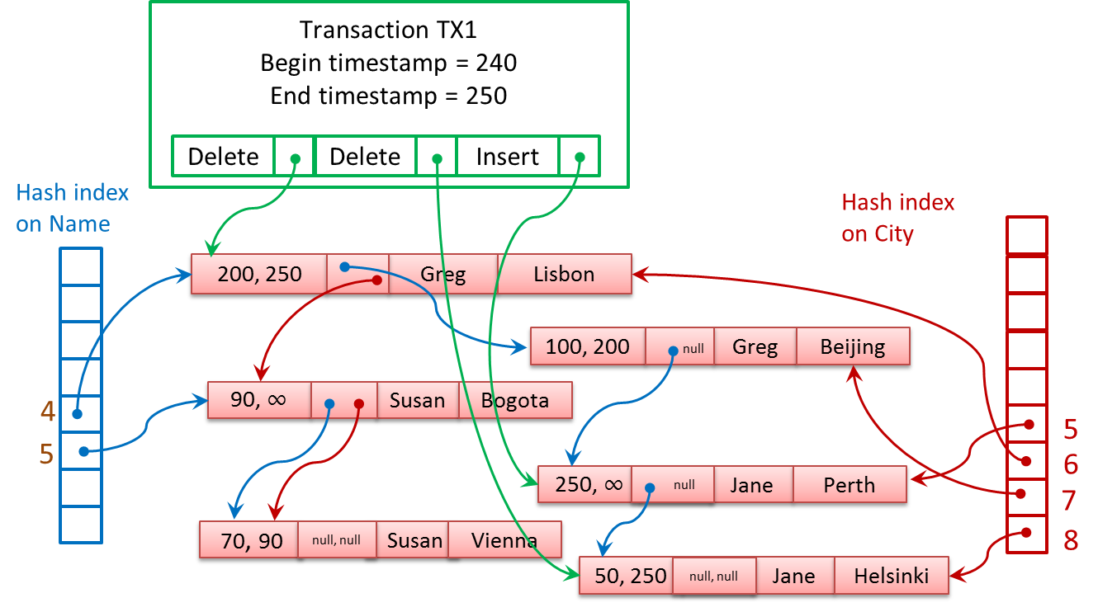

Figure 8 Transactional Modifications on a table

### Reading

Now let’s look at the read transactions, TX2 and TX3, which will be processed concurrently with TX1. Remember that TX1 is deleting the row <Greg , Lisbon> and updating <Jane, Helsinki> to <Jane, Perth> .

TX2 is an autocommit transaction that reads the entire table:

SELECT Name, City   
FROM T1

TX2’s session is running in the default isolation level READ COMMITTED, but as described above, because no hints are specified, and T1 is memory-optimized table, the data will be accessed using SNAPSHOT isolation. Because TX2 runs at timestamp 243, it will be able to read rows that existed at that time. It will not be able to access <Greg, Beijing> because that row no longer is valid at timestamp 243. The row <Greg, Lisbon> will be deleted as of timestamp 250, but it is valid between timestamps 200 and 250, so transaction TX2 can read it. TX2 will also read the <Susan, Bogota> row and the <Jane, Helsinki> row.

TX3 is an explicit transaction that starts at timestamp 246. It will read one row and update another based on the value read.

DECLARE @City nvarchar(32);  
BEGIN TRAN TX3  
 SELECT @City = City   
 FROM T1 WITH (REPEATABLEREAD)  
 WHERE Name = 'Jane';

UPDATE T1 WITH (REPEATABLEREAD)  
 SET City = @City  
 WHERE Name = 'Susan';  
COMMIT TRAN -- commits at timestamp 255

In TX3, the SELECT will read the row <Jane, Helsinki> because that row still is accessible as of timestamp 243. It will then update the <Susan, Bogota> row to <Susan, Helsinki>. However, if transaction TX3 tries to commit after TX1 has committed, SQL Server will detect that the <Jane, Helsinki> row has been updated by another transaction. This is a violation of the requested REPEATABLE READ isolation, so the commit will fail and transaction TX3 will roll back. We’ll see more about validation in the next section.

### Validation

Prior to the final commit of transactions involving memory-optimized tables, SQL Server performs a validation step. Because no locks are acquired during data modifications, it is possible that the data changes could result in invalid data based on the requested isolation level. So this phase of the commit processing makes sure that there is no invalid data.

The following list shows you some of the possible violations that can be encountered in each of the possible isolation levels. More possible violations, as well as commit dependencies, will be discussed in the next paper when isolation levels and concurrency control will be described in greater detail.

If memory-optimized tables are accessed in SNAPSHOT isolation, the following validation errors are possible when a COMMIT is attempted:

* If the current transaction inserted a row with the same primary key value as a row that was inserted by another transaction that committed before the current transaction, error 41325 (“The current transaction failed to commit due to a serializable validation failure.”) will be generated and the transaction will be aborted.

If memory-optimized tables are accessed in REPEATABLE READ isolation, the following additional validation error is possible when a COMMIT is attempted:

* If the current transaction has read any row that was then updated by another transaction that committed before the current transaction, error 41305 (“The current transaction failed to commit due to a repeatable read validation failure.”) will be generated and the transaction will be aborted.

If memory-optimized tables are accessed in SERIALIZABLE isolation, the following additional validation errors are possible when a COMMIT is attempted:

* If the current transaction fails to read any valid rows that meet the specifed filter conditions, or encounters phantoms rows inserted by other transactions that meet the specified filter conditions, the commit will fail. The transaction needs to be executed as if there are no concurrent transactions. All actions logically happen at a single serialization point. If any of these guarantees are violated, error 41325 is generated and the transaction will be aborted.

### T-SQL Support

Memory-optimized tables can be accessed in two different ways: either through interop, using interpreted Transact-SQL, or through natively compiled stored procedures.

#### Interpreted Transact-SQL

When using the interop capability, you will have access to virtually the full Transact-SQL surface area when working with your memory-optimized tables, but you should not expect the same performance as when you access memory-optimized tables using natively compiled stored procedures. Interop is the appropriate choice when running ad hoc queries, or to use while migrating your applications to In-Memory OLTP, as a step in the migration process, before migrating the most performance critical procedures. Interpreted Transact-SQL should also be used when you need to access both memory-optimized tables and disk-based tables.

The only Transact-SQL features not supported when accessing memory-optimized tables using interop are the following:

* TRUNCATE TABLE
* MERGE (when a memory-optimized table is the target)
* Dynamic and keyset cursors (these are automatically degraded to static cursors)
* Cross-database queries
* Cross-database transactions
* Linked servers
* Locking hints: TABLOCK, XLOCK, PAGLOCK, etc. (NOLOCK is supported, but is quietly ignored.)
* Isolation level hints READUNCOMMITTED, READCOMMITTED and READCOMMITTEDLOCK

#### T-SQL in Natively Compiled Procedures

Natively compiled stored procedures allow you to execute Transact-SQL in the fastest way, which includes accessing data in memory-optimized tables. There are however, many more limitations on the Transact-SQL that is allowed in these procedures. There are also limitations on the data types and collations that can be accessed and processed in natively compiled procedures. Please refer to the documentation for the full list of supported Transact-SQL statements, data types and operators that are allowed. In addition, disk-based tables are not allowed to be accessed at all inside natively compiled stored procedures.

The reason for the restrictions is due to the fact that internally, a separate function must be created for each operation on each table. The interface will be expanded in subsequent versions.

### Garbage Collection of Rows in Memory

Because In-Memory OLTP is a multi-versioning system, your DELETE and UPDATE operations (as well as aborted INSERT operations) will generate row versions that will eventually become stale, which means they will no longer be visible to any transaction. These unneeded versions will slow down scans of index structures and create unused memory that needs to be reclaimed.

The garbage collection process for stale versions in your memory-optimized tables is analogous to the version store cleanup that SQL Server performs for disk-based tables using one of the snapshot-based isolation levels. A big difference though is that the cleanup is not done in *tempdb*, but in the in-memory table structures themselves.

To determine which rows can be safely deleted, the system keeps track of the timestamp of the oldest active transaction running in the system, and uses this value to determine which rows are still potentially needed. Any rows that are not valid as of this point in time (that is, their end-timestamp is earlier than this time) are considered *stale*. Stale rows can be removed and their memory can be released back to the system.

The garbage collection system is designed to be non-blocking, cooperative, efficient, responsive and scalable. Of particular interest is the ‘cooperative’ attribute. Although there is a dedicated system thread for the garbage collection process, user threads actually do most of the work. If a user thread is scanning an index (and all index access on memory-optimized tables is considered to be scanning) and it comes across a stale row version, it will unlink that version from the current chain and adjust the pointers. It will also decrement the reference count in the row header area. In addition, when a user thread completes a transaction, it then adds information about the transaction to a queue of transactions to be processed by the garbage collection process. Finally, it picks up one or more work items from a queue created by the garbage collection thread, and frees the memory used by the rows making up the work item.

The garbage collection thread goes through the queue of completed transactions about once a minute, but the system can adjust the frequency internally based on the number of completed transactions waiting to be processed. From each transaction, it determines which rows are stale, and builds work items made up of a set of rows that are ready for removal. In CTP2, the number of rows in a set is 16, but that number is subject to change in future versions. These work items are distributed across multiple queues, one for each CPU used by SQL Server. Normally, the work of actually removing the rows from memory is left to the user threads which process these work items from the queues, but if there is little user activity, the garbage collection thread itself can remove rows to reclaim system memory.

The DVM *sys.dm_db_xtp_index_stats* has a row for each index on each memory-optimized table, and the column *rows_expired* indicates how many rows have been detected as being stale during scans of that index. There is also a column called *rows_expired_removed* that indicates how many rows have been unlinked from that index. As mentioned above, once rows have been unlinked from all indexes on a table, it can be removed by the garbage collection thread. So you will not see the *rows_expired_removed* value going up until the *rows_expired* counters have been incremented for every index on a memory-optimized table.

The following query allows you to observe these values. It joins the *sys.dm_db_xtp_index_stats* DMVwith the *sys.indexes* catalog view to be able to return the name of the index.

SELECT name AS 'index_name', s.index_id, scans_started, rows_returned,   
 rows_expired, rows_expired_removed

FROM sys.dm_db_xtp_index_stats s JOIN sys.indexes i   
 ON s.object_id=i.object_id and s.index_id=i.index_id

WHERE object_id('<memory-optimized table name>') = s.object_id;

GO

# Transaction Isolation and Concurrency Management

As mentioned above, all access of data in memory-optimized tables is done using completely optimistic concurrency control, but multiple transaction isolation levels are still allowed. However, what isolation levels are allowed in what situations might seem a little confusing and non-intuitive. The isolation levels we are concerned about are the ones involving a ***cross container transaction,*** which means any interpreted query that references memory-optimized tables whether executed from an explicit or implicit transaction or in auto-commit mode. The isolation levels that can be used with your memory-optimized tables in a cross-container transaction depend on what isolation level the transaction has defined for the SQL Server transaction. Most of the restrictions have to do with the fact that operations on disk-based tables and operations on memory-optimized tables each have their own transaction sequence number, even if they are accessed in the same Transact-SQL transaction. You can think of this behavior as having two sub-transactions within the larger transaction: one sub-transaction is for the disk-based tables and one is for the memory-optimized tables.

First, let me give you a little background on isolation levels in general. This will not be a complete discussion of isolation levels, which is beyond the scope of this paper. Isolation levels can be defined in terms of the consistency properties that are guaranteed. The most important properties are the following:

1. Read Stability. If T reads some version V1 of a record during its processing, we must guarantee that V1 is still the version visible to T as of the end of the transaction, that is, V1 has not been replaced by another committed version V2. This can be implemented either by read locking V1 to prevent updates or by validating that V1 has not been updated before commit.
2. Phantom Avoidance. We must be able to guarantee that a transaction T’s scans would not return additional new versions added between the time T starts and the time T commits. This can be implemented in two ways: by locking the scanned part of an index/table or by rescanning to check for new versions before commit.

Then we can define the transaction isolation level based on these properties. The first one listed (SNAPSHOT) does not mention these properties, but the second two do.

* SNAPSHOT

This isolation level specifies that data read by any statement in a transaction will be the transactionally consistent version of the data that existed at the start of the transaction. The transaction can only recognize data modifications that were committed before the start of the transaction. Data modifications made by other transactions after the start of the current transaction are not visible to statements executing in the current transaction. The statements in a transaction get a snapshot of the committed data as it existed at the start of the transaction.

* REPEATABLE READ

This isolation level includes the guarantees given by SNAPSHOT isolation level. In addition, REPEATABLE READ guarantees Read Stability. For any row that is read by the transaction, at the time the transaction commits the row has not been changed by any other transaction. Every read operation in the transaction is repeatable up to the end of the transaction.

* SERIALIZABLE

This isolation level includes the guarantees given by the REPEATABLE READ isolation level. In addition, SERIALIZABLE guarantees Phantom Avoidance. The operations in the transaction have not missed any rows. No phantom rows have appeared between time of the snapshot and the end of the transaction. Phantom rows match the filter condition of a SELECT/UPDATE/DELETE. A transaction is serializable if we can guarantee that it would see exactly the same data if all its reads were repeated at the end of the transaction.

The simplest and most widely used MVCC method is snapshot isolation (SI) but SI does not guarantee serializability because reads and writes logically occur at different times, reads at the beginning of the transaction and writes at the end.

Access to disk-based tables also support READ COMMITTED isolation, which simply guarantees that the transaction will not read any dirty (uncommitted) data. Access to memory-optimized tables needs to use one of the three isolation levels mentioned above. Table 1 lists which isolation levels can be used together in a cross-container transaction.

|  |  |  |
| --- | --- | --- |
| **Disk-based tables** | **Memory-optimized tables** | **Recommendations** |
| READ COMMITTED | SNAPSHOT | This is the baseline combination and should be used for most situations using READ COMMITTED currently |
| READ COMMITTED | REPEATABLE READ / SERIALIZABLE | This combination can be used during data migration and for memory-optimized table access in interop mode (not in a natively compiled procedure). |
| REPEATABLE READ / SERIALIZABLE | SNAPSHOT | The access for memory-optimized tables is only INSERT operations. This combination can also be useful during migration and if no concurrent write operations are being performed on the memory-optimized tables. |
| SNAPSHOT | - | No memory-optimized table access allowed (see note 1) |
| REPEATABLE READ / SERIALIZABLE | REPEATABLE READ / SERIALIZABLE | This combination is not allowed (see note 2) |

Table 1 Compatible isolation levels in cross-container transactions

Note 1: For SHAPSHOT Isolation, all operations need to see the versions of the data that existed as of the beginning of the transaction. For SNAPSHOTs, the beginning of the transaction is measured when the first table is accessed. In a cross-container transaction, however, since the sub-transactions can each start at a different time, another transaction may have changed data between the start times of the two sub-transactions. The cross-container transaction then will have no one point in time that the snapshot is based on.

Note 2: The reason both the sub-transactions (the one on the disk-based tables and the one on the memory-optimized tables) can’t use REPEATABLE READ or SERIALZABLE is because the two systems implement the isolation levels in different ways. Imagine the two cross-container transactions in Figure 9.

|  |  |  |
| --- | --- | --- |
| **Time** | **Tx1 (SERIALIZBLE)** | **Tx2 (any isolation level)** |
| 1 | BEGIN SQL/In-Memory sub-xacts |  |
| 2 | Read RHk1 |  |
| 3 |  | BEGIN SQL/In-Memory sub-transactions |
| 4 |  | Read RSql1 and update to RSql2 |
| 5 |  | Read RHk1 and update to RHk2 |
| 6 |  | COMMIT |
| 7 | Read RSql2 |  |

Figure 9 Two concurrent cross-container transactions

Tx1 would read the row from the memory-optimized table first and no locks would be held, so that Tx2 could complete and change the two rows. When Tx1 resumed, when it read the row from the disk-based table, it would now have a set of values for the two rows that could never have existed if the transaction were run in isolation (i.e. if the transaction were truly serializable.) So this combination is not allowed.

For more details on Isolation Levels, please see the following references:  
 <http://en.wikipedia.org/wiki/Isolation_(database_systems)>   
 <http://research.microsoft.com/apps/pubs/default.aspx?id=69541>

# Durability and Storage for Memory-optimized Tables

SQL Server must ensure transaction durability for memory-optimized tables, so that the effects of all committed transactions can be recovered after a failure. In-Memory OLTP achieves this by having both the checkpoint process and the transaction logging process write to durable storage. Though not covered in this paper, In-Memory OLTP is also integrated with the AlwaysOn Availability Group feature that maintains highly available replicas supporting failover.

The information written to disk consists of checkpoint streams and transaction log streams.

* *Log streams* contain the changes made by committed transactions.
* *Checkpoint streams* come in two varieties:
  + *data streams* contain all row versions inserted during a timestamp interval
  + *delta streams* are associated with a particular data stream and contain a list of integers indicating which row versions in its corresponding data stream have been deleted.

Checkpoint streams are organized temporally. A pair of checkpoint files, data and delta, represent a segment of transaction log, generally containing about 100MB of new row versions.

These checkpoint file pairs (CFPs) accumulate to form a complete checkpoint (which is described in more detail later in this section). The most recent completed checkpoint combined with the recent transaction log since the checkpoint are sufficient to recover the in-memory state of memory-optimized tables to a transactionally consistent point in time that includes all committed transactions. Before we go into more detail of how the log and the checkpoint files are generated and used, here are a few crucial points to keep in mind:

* Log streams are stored in the regular SQL Server transaction log.
* Checkpoint streams are stored in SQL Server filestream files which in essence are sequential files fully managed by SQL Server. (Filestream storage was introduced in SQL Server 2008 and In-Memory OLTP checkpoint files take advantage of that technology. For more details about filestream storage and management, see this whitepaper: <http://msdn.microsoft.com/en-us/library/hh461480.aspx> )
* The transaction log contains required information about committed transactions to redo the transactions. The changes are recorded as inserts and deletes of row versions marked with the table they belong to. No undo information is written to the transaction log.
* Index operations on memory-optimized tables are not logged. All indexes are completely rebuilt on recovery.

## Transaction Logging

In-Memory OLTP’s transaction logging is designed for both scalability and high performance. Each transaction is logged in a minimal number of potentially large log records that are written to SQL Server’s regular transaction log. The log records contain information about all versions inserted and deleted by the transaction. Updates are logged as the deletion of the old version of the row and the insertion of the new version of the row. Using this information, the transaction can be redone during recovery.

For In-Memory OLTP transactions, log records are generated only at commit time. In-Memory OLTP does not use a write-ahead logging (WAL) protocol, such as used when processing operations on disk-based tables. With WAL, SQL Server writes to the log before writing any changed data to disk, and this can happen even for uncommitted data written out during checkpoint. For In-Memory OLTP, dirty data (i.e. uncommitted changes) are never written to disk. Furthermore, In-Memory OLTP tries to group multiple log records into one large log record of up to 24kb which results in fewer log records actually written, and larger I/Os.

In-Memory OLTP operations can generate less log data and fewer log writes compared with operations on disk-based tables. The following simple script illustrates the greatly reduced logging for memory-optimized tables. This script creates a database that can hold memory-optimized tables, and then creates two similar tables. One is a memory-optimized table, and one is a disk-based table.

USE master

GO

IF EXISTS (SELECT * FROM sys.databases WHERE name='LoggingDemo')

DROP DATABASE LoggingDemo;

GO

CREATE DATABASE LoggingDemo ON

PRIMARY (NAME = [LoggingDemo_data], FILENAME = 'C:\DataHK\LoggingDemo_data.mdf'),

FILEGROUP [LoggingDemo_FG] CONTAINS MEMORY_OPTIMIZED_DATA

(NAME = [LoggingDemo_container1], FILENAME = 'C:\DataHK\StorageDemo_mod_container1')

LOG ON (name = [hktest_log], Filename='C:\DataHK\StorageDemo.ldf', size=100MB);

GO

USE LoggingDemo

GO

IF EXISTS (SELECT * FROM sys.objects WHERE name='t1_inmem')

DROP TABLE [dbo].[t1_inmem]

GO

-- create a simple memory-optimized table

CREATE TABLE [dbo].[t1_inmem]

( [c1] int NOT NULL,

[c2] char(100) NOT NULL,

CONSTRAINT [pk_index91] PRIMARY KEY NONCLUSTERED HASH ([c1]) WITH(BUCKET_COUNT = 1000000)

) WITH (MEMORY_OPTIMIZED = ON,

DURABILITY = SCHEMA_AND_DATA);

GO

IF EXISTS (SELECT * FROM sys.objects WHERE name='t1_disk')

DROP TABLE [dbo].[t1_disk]

GO

-- create a similar disk-based table

CREATE TABLE [dbo].[t1_disk]

( [c1] int NOT NULL,

[c2] char(100) NOT NULL)

GO

CREATE UNIQUE NONCLUSTERED INDEX t1_disk_index on t1_disk(c1);

GO

Next, populate the disk-based table with 100 rows, and examine the contents of the transaction log using the undocumented (and unsupported) function fn_dblog().

BEGIN TRAN

DECLARE @i int = 0

WHILE (@i < 100)

BEGIN

INSERT INTO t1_disk VALUES (@i, replicate ('1', 100))

SET @i = @i + 1

END

COMMIT

-- you will see that SQL Server logged 200 log records

SELECT * FROM sys.fn_dblog(NULL, NULL)

WHERE PartitionId IN

(SELECT partition_id FROM sys.partitions

WHERE object_id=object_id('t1_disk'))

ORDER BY [Current LSN] ASC;

GO

Now run a similar update on the memory-optimized table, and you’ll see only three log records, similar to Figure 10.

BEGIN TRAN

DECLARE @i int = 0

WHILE (@i < 100)

BEGIN

INSERT INTO t1_inmem VALUES (@i, replicate ('1', 100))

SET @i = @i + 1

END

COMMIT

-- look at the log

SELECT * FROM sys.fn_dblog(NULL, NULL) order by [Current LSN] DESC;

GO

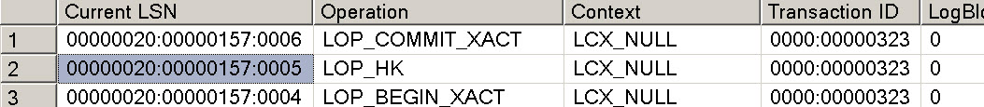

Figure 10 SQL Server transaction log showing one log record for 100 row transaction

The output shows that all 100 inserts have been logged in a single log record, of type LOP_HK. LOP indicates a ‘logical operation’ and HK is an artifact from the project codename, Hekaton. Another undocumented, unsupported function can be used to break apart a LOP_HK record. You’ll need to replace the LSN value with whatever the LSN is for you LOP_HK record.

SELECT [current lsn], [transaction id], operation,

operation_desc, tx_end_timestamp, total_size,

object_name(table_id) AS TableName

FROM sys.fn_dblog_xtp(null, null)

WHERE [Current LSN] = '00000020:00000157:0005';

The first few rows of output should look like Figure 11.

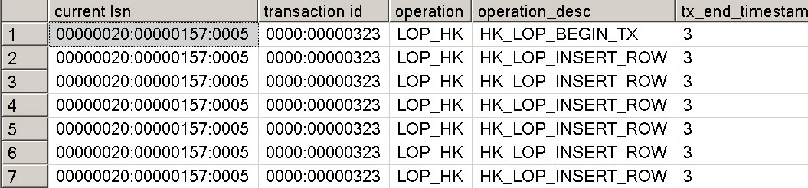

Figure 11 Breaking apart the log record for the inserts on the memory-optimized table shows the individual rows affected

The single log record for the entire transaction on the memory-optimized table, plus the reduced size of the logged information, helps to make transactions on memory-optimized tables much more efficient.

## Checkpoint

Just like for operations on disk-based tables, one of the main reasons for checkpoint operations is to reduce recovery time. The checkpointing process for memory-optimized tables is designed to satisfy two important requirements.

* **Continuous Persistence**. A background thread consciously scans transaction log records and populates the data /delta files on disk.
* **Streaming I/O**. Writing of data /delta files is done in an append-only manner by appending newly created rows to the end of the current data file and by appending the deleted rows to the corresponding delta file.

Checkpointing is the continuous process of constructing checkpoint files, namely data files and delta files, from the transaction log.

A **data file** contains only inserted versions or rows, which, as we saw earlier are generated by both INSERT and UPDATE operations. Each file covers a specific timestamp range. All versions with a begin timestamp within the data file’s range are contained in the file. Data files are append-only while they are open and once they are closed, they are strictly read-only. At recovery time the valid versions in the data files are reloaded into memory and reindexed.

**A delta file** stores information about which versions contained in a data file have been subsequently deleted. There is a 1:1 correspondence between delta files and data files. Delta files are append-only for the lifetime of the data file they correspond to. At recovery time, the delta file is used as a filter to avoid reloading deleted versions into memory. Because each data file is paired with exactly one delta file, the smallest unit of work for recovery is a data/delta file pair. This allows the recovery process to be highly parallelizable.

The data and delta files are allocated in pairs again referred to as Checkpoint File Pair (CFP). A maximum of 8192 CFPs are supported in a database.

### Completing a Checkpoint

The checkpoint operation for memory-optimized tables is independent of the checkpoint for disk-based tables. The automatic checkpoint for disk-based tables is controlled by recovery interval and it has no bearing on the checkpoint for memory-optimized tables. A complete checkpoint of memory-optimized tables consists of multiple data and delta files, plus a **checkpoint file inventory** that contains references to all the data and delta files that make up a complete checkpoint. The completion of a checkpoint involves flushing the latest content of data and delta files to disk and constructing the inventory which is written to the transaction log.

Checkpoints are completed in two ways automatic and manual:

* **Automatic** **checkpoint completion**: It is done when the transaction log since the last automatic checkpoint exceeds 512MB. In other words, an automatic checkpoint is kicked off for every 512MB of log records accumulated containing changes both from memory-optimized and disk-based tables. Unlike checkpoint for disk-based tables, the persistence of the data for memory-optimized tables is done continuously by a background thread, the completion of a checkpoint updates internal metadata information.
* **Manual** **checkpoint completion**: when an explicit CHECKPOINT command is issued, it initiates checkpoint operations on both disk-based tables and memory-optimized tables

A complete checkpoint combined with the tail of the transaction log enables memory-optimized tables to be recovered. A checkpoint has a timestamp which indicates that the effects of all transactions before the checkpoint timestamp are recorded in the checkpoint and thus the transaction log is not needed to recover those earlier transactions.

## Merging of Checkpoint Files

The set of files involved in a checkpoint grows with each check-point. However the active content of a data file decreases as more and more of its versions are marked as deleted in the corresponding delta file. Since the recovery process will read the contents of all data and delta files in the checkpoint, performance of crash recovery degrades as the relevant number of rows in each data file decreases.

The checkpoint system hands this through an automatic process called *merge.* SQL Server 2014 implements the following merge policy:

* A merge is scheduled if 2 or more consecutive CFPs can be consolidated, after accounting for deleted rows, such that the resultant rows can fit into 1 CFP of ideal size. The ideal size of CFP is determined as follows
  + For machines < 16GB. The data file is 16MB and delta file is 1MB
  + For machines > 16GB, the data file is 128MB and delta file is 8MB
* A single CFP can be self-merged the data file exceeds 256 MB and over half of the rows are deleted. A data file can grow larger than 128MB if, for example, a single transaction or multiple concurrent transactions insert/update large amount of data forcing the data file to grow beyond its ideal size because a transaction cannot span multiple CFPs.

### Automatic Merge

To identify files to be merged, a background task periodically looks at all active data/delta checkpoint file pairs and identifies zero or more sets of CFPs that qualify for merge operation. Each set can contain one or more data/delta file pairs that are adjacent to each other such that the resultant set of rows can still fit in a single data file of size 128MB. Figure 12 shows are some examples of files that will be chosen to be merged under the merge policy.

|  |  |
| --- | --- |
| **Adjacent Source Files (%full)** | **Merge Selection** |
| DF0 (30%) DF1 (50%), DF2 (50%), DF3 (90%) | (DF1, DF2) |
| DF0 (30%) DF1 (20%), DF2 (50%), DF3 (10%) | (F0, F1, F2). Files are chosen starting from left |
| DF0 (80%), DF1 (10%), DF2 (10%), DF3(20%) | (DF0, DF1, DF2). Files are chosen starting from left |

Figure 12 Examples of files that can be chosen for file merge operations

It is possible that two adjacent data files are 60% full. They will not be merged and 40% of storage is unused. So effectively, the total disk storage used for durable memory-optimized tables is larger than the corresponding memory-optimized size.

### Manual Merge sys.sp_xtp_merge_checkpoint_files

In most cases, the automatic merging of checkpoint files will be sufficient to keep the number of files to a manageable number. However, in rare situations, or for testing purposes, you might want to use a manual merge. More information can be found here: <http://blogs.technet.com/b/dataplatforminsider/archive/2014/01/22/merge-operation-in-memory-optimized-tables.aspx>

## Storage Considerations for Checkpoint Files

The size of storage space taken by durable tables can be significantlylarger than the corresponding memory-optimized size assuming the merge and data persistence is keeping up. The recommended limit for the total in-memory size of all durable tables in a database is 250 GB. Durable tables requiring 250 GB of space in memory will, assuming a mix of insert/delete/update operations, require on average 500 GB of storage space in the memory optimized file group spanning 4000 data/delta file pairs. Bursts of activity in the database may cause checkpoint and merge operations to fall behind for a period of time and thus increasing the number of files required.  As a cushion for such bursts, the storage system supports up to 8000 data/delta file pairs or 1TB of storage and when that limit is reached new transactions on the database will be prevented until checkpoint operations catch up.  The cushion of the 8000 data/delta file pairs allows for total in-memory size of durable tables to exceed 250GB but care should be taken in exceeding this for long periods of time due to the increased risk of hitting the 8000 limit. When limit of 8000 CFPs is hit, you can reduce the number of CFPs by forcing manual merges as described in the previous section. Note, manual merges are allowed to exceed the limit of 8000 CFPs up to 8192 CFPs to enable customers some flexibility in troubleshooting were the CFPs to hit 8000.

### Garbage Collection of Checkpoint Files

Once the merge operation is complete, the source files are not needed and can potentially be removed by the garbage collection process at a later time as long as regular log backups are taken. Before a checkpoint file can be removed, the In-Memory OLTP engine must ensure that it will not be required. In general, the garbage collection process is automatic, and does not require any intervention. However, there is an option to force the garbage collection of unused checkpoint files.

The DMV *sys.dm_db_xtp_checkpoint_files* can be queried to list all the CFPs in memory-optimized filegroup including the phase they are in. For details on this DMV, see http://blogs.technet.com/b/dataplatforminsider/archive/2014/01/22/merge-operation-in-memory-optimized-tables.aspx.

## Recovery

Recovery on In-Memory OLTP tables starts after the location of the most recent check-point inventory has been recovered during a scan of the tail of the log. Once the SQL Server host has communicated the location of the checkpoint inventory to the In-Memory OLTP engine, SQL Server and In-Memory OLTP recovery proceed in parallel.

In-Memory OLTP recovery itself is parallelized. Each delta file represents a filter for rows that need not be loaded from the corresponding data file. This data/delta file pair arrangement means that check-point load can proceed in parallel across multiple IO streams with each stream processing a single data file and delta file. The In-Memory OLTP engine creates one thread per core to handle parallel insertion of the data produced by the I/O streams. The insert threads load into memory (and all indexes) all active rows in the data file after removing the rows that have been deleted. The choice of one thread per core means that the load process is performed as efficiently as possible.

Finally, once the checkpoint load process completes, the tail of the transaction log is replayed from the timestamp of the checkpoint, with the goal of bringing the database back to the state that existed at the time of the crash.

# Native Compilation of Tables and Stored Procedures

In-Memory OLTP introduces the concept of native compilation to SQL Server 2014. SQL Server can natively compile stored procedures that access memory-optimized tables, and, in fact, also natively compiles memory-optimized tables themselves. Native compilation allows faster data access and more efficient query execution than traditional interpreted Transact-SQL provides.

## What is native compilation?

Native compilation refers to the process of converting programming constructs to native code, consisting of processor instructions that can be executed directly by the CPU, without the need for further compilation or interpretation.

The Transact-SQL language consists of high-level constructs such as CREATE TABLE and SELECT … FROM. The In-Memory OLTP compiler takes these constructs, and compiles them down to native code for fast runtime data access and query execution. The In-Memory OLTP compiler in SQL Server 2014 takes the table and stored procedures definitions as input. It generates C code, and leverages the Visual C compiler to generate the native code.

The result of the compilation of tables and stored procedures are DLLs that are loaded in memory and linked into the SQL Server process.

SQL Server compiles both memory-optimized tables and natively compiled stored procedures to native DLLs at create time. In addition, the table and stored procedure DLLs are recompiled after database or server restart. The information necessary to recreate the DLLs is stored in the database metadata; the DLLs themselves are not part of the database. Thus, for example, the DLLs are not part of database backups.

## Maintenance of DLLs

The DLLs for memory optimized tables and natively compiled stored procedures are stored in the filesystem, along with other generated files, which are kept for troubleshooting and supportability purposes.

The following query shows all table and stored procedure DLLs currently loaded in memory on the server:

SELECT name, description FROM sys.dm_os_loaded_modules

WHERE description = 'XTP Native DLL'

Database administrators do not need to maintain the files that are generated by native compilation. SQL Server automatically removes generated files that are no longer needed, for example on table and stored procedure deletion, and on drop database, but also on server or database restart.

## Native compilation of tables

Creating a memory optimized table using the CREATE TABLE statement results in the table information being written to the database metadata, table and index structures being created in memory, and also the table being compiled to a DLL.

Consider the following sample script, which creates a database and a single memory optimized table:

USE master

GO

create database db1

GO

ALTER DATABASE db1 ADD FILEGROUP db1_mod CONTAINS memory_optimized_data

GO

-- adapt filename as needed

ALTER DATABASE db1 ADD FILE (name='db1_mod', filename='c:\data\db1_mod')   
 TO FILEGROUP db1_mod

GO

USE db1

GO

CREATE TABLE dbo.t1

(c1 int not null primary key nonclustered,

c2 int)

WITH (MEMORY_OPTIMIZED=ON)

GO

-- retrieve the path of the DLL for table t1

SELECT name, description FROM sys.dm_os_loaded_modules

WHERE name LIKE '%xtp_t_' + cast(db_id() AS varchar(10))   
 + '_' + cast(object_id('dbo.t1') AS varchar(10)) + '.dll'

GO

The table creation results in the compilation of the table DLL, and also loading that DLL in memory. The DMV query immediately after the CREATE TABLE statement retrieves the path of the table DLL.

The table DLL for t1 understands the index structures and row format of the table. SQL Server uses the DLL for traversing indexes and retrieving rows, as well as the contents of the rows.

## Native compilation of stored procedures

Stored procedures that are marked with NATIVE_COMPILATION are natively compiled. This means the Transact-SQL statements in the procedure are all compiled down to native code, for efficient execution of performance-critical business logic.

Consider the following sample stored procedure, which inserts rows in the table t1 from the previous example:

CREATE PROCEDURE dbo.p1

WITH NATIVE_COMPILATION, SCHEMABINDING, EXECUTE AS OWNER

AS

BEGIN ATOMIC

WITH (TRANSACTION ISOLATION LEVEL=snapshot, LANGUAGE=N'us_english')

DECLARE @i int = 1000000

WHILE @i > 0

BEGIN

INSERT dbo.t1 VALUES (@i, @i+1)

SET @i -= 1

END

END

GO

EXEC dbo.p1

GO

-- reset

DELETE FROM dbo.t1

GO

The DLL for the procedure p1 can interact directly with the DLL for the table t1, as well as the In-Memory OLTP storage engine, to insert the rows as fast as possible.

The In-Memory OLTP compiler leverages the query optimizer to create an efficient execution plan for each of the queries in the stored procedure. Note that, for natively compiled stored procedures, the query execution plan is compiled into the DLL. Because SQL Server 2014 does not support automatic recompilation of natively compiled stored procedures, changes to table data may require dropping and recreating certain procedures to allow incorporating new query plans into the stored procedure DLLs. Note that natively compiled stored procedures are recompiled on first execution after server restart, as well as after failover to an AlwaysOn secondary, meaning that the query optimizer will create new query plans that are subsequently compiled into the stored procedure DLLs.

### Compilation and Query Processing

Figure 15 illustrates the compilation process for natively compiled stored procedures:



Figure 15: Native compilation of stored procedures

1. The user issues a CREATE PROCEDURE statement to SQL Server
2. The parser and algebrizer create the processing flow for the procedure, as well as query trees for the Transact-SQL queries in the stored procedure
3. The optimizer creates optimized query execution plans for all the queries in the stored procedure
4. The In-Memory OLTP compiler takes the processing flow with the embedded optimized query plans and generates a DLL that contains the machine code for executing the stored procedure
5. The generated DLL is loaded in memory and linked to the SQL Server process

Invocation of a natively compiled stored procedure translates to calling a function in the DLL, as shown in Figure 16



Figure 16: Execution of natively compiled stored procedures

1. The user issues an ‘EXEC *myproc*’ statement
2. The parser extracts the name and stored procedure parameters
3. The In-Memory OLTP runtime locates the DLL entry point for the stored procedure
4. The DLL executes the procedure logic and returns the results to the client

**Parameter sniffing**

Interpreted Transact-SQL stored procedures are compiled into intermediate physical execution plans at first execution (invocation) time, in contrast to natively compiled stored procedures, which are natively compiled at create time. When interpreted stored procedures are compiled at invocation, the values of the parameters supplied for this invocation are used by the optimizer when generating the execution plan. This use of parameters during compilation is called “parameter sniffing”.

Parameter sniffing is not used for compiling natively compiled stored procedures. All parameters to the stored procedure are considered to have UNKNOWN values.

# SQL Server Feature Support

Many SQL Server features are supported for In-Memory OLTP and databases containing memory-optimized tables, but not all. For example, AlwaysOn components, log shipping, and database backup and restore are fully supported. There is partial support for transactional replication allowing memory-optimized tables to be used as a subscription but not as a published article. However, database mirroring is not supported. You can use SQL Server Management Studio to work with memory-optimized tables and SSIS is also supported.

For the full list of supported and unsupported features, please refer to the SQL Server In-Memory OLTP documentation.

## Manageability Experience

In-Memory OLTP is completely integrated into the manageability experience of SQL Server. As mentioned above, SQL Server Management Studio is able to work with your memory-optimized tables, filegroups and natively compiled procedures. In addition, you can use Server Management Objects (SMO) and PowerShell to manage your memory-optimized objects.

# Metadata

Several existing metadata objects have been enhanced to provide information about memory-optimized tables and procedures and new objects have been added.

There is one function that has been enhanced:

* *OBJECTPROPERTY* – now includes a property *TableIsMemoryOptimized*

## Catalog Views

The following system views have been enhanced:

* *sys.tables* – has three new columns:
  + *durability* (0 or 1)
  + *durability_desc* (SCHEMA_AND_DATA and SCHEMA_ONLY)
  + *is_memory_optimized* (0 or 1)
* *sys.table_types* – now has a column *is_memory_optimized*
* *sys.indexes* – now has a possible *type* value of 7 and a corresponding *type_desc* value of NONCLUSTERED HASH. (nonclustered indexes have a *type_value* of 2 and a *type_desc* of NONCLUSTERED, just as for a nonclustered B-tree index.)
* *sys.index_columns*  now has different semantics for the column *is_descending_key*, in that for HASH indexes, the value is meaningless and ignored.
* *sys.data_spaces* -- now has a possible *type* value of FX and a corresponding *type_desc* value of MEMORY_OPTIMIZED_DATA_FILEGROUP
* *sys.sql_modules* and *sys.all_sql_modules* – now contain a column *uses_native_compilation*

In addition, there are several new metadata objects that provide information specifically for memory-optimized tables.

A new catalog view has been added to support hash indexes: *sys.hash_indexes*. This view is based on *sys.indexes* so has the same columns as that view, with one extra column added. The *bucket_count* column shows a count of the number of hash buckets specified for the index and the value cannot be changed without dropping and recreating the index.

## Dynamic Management Objects

The following SQL Server Dynamic Management Views are new for In-Memory OLTP. (The *xtp* identifier stands for ‘eXtreme transaction processing’.) The ones that start with *sys.dm_db_xtp_\** give information about individual In-Memory OLTP -enabled databases, where the ones that start with *sys.dm_xtp_\** provide instance-wide information. You can read about the details of these objects in the documentation. Some of these DMVs have already been mentioned in earlier relevant sections of this paper.

For more information about DMVs that support memory-optimized tables, see [Memory-Optimized Table Dynamic Management Views](http://msdn.microsoft.com/en-us/library/dn133203(v=sql.120).aspx) (http://msdn.microsoft.com/en-us/library/dn133203(v=sql.120).aspx).

* [sys.dm_db_xtp_checkpoint](mk:@MSITStore:C:\SQL%20Server\Hekaton\Sql_Hekaton.chm::/html/8d0b18ca-db4d-4376-9905-3e4457727c46.htm)
* [sys.dm_db_xtp_checkpoint_files](mk:@MSITStore:C:\SQL%20Server\Hekaton\Sql_Hekaton.chm::/html/ac8e6333-7a9f-478a-b446-5602283e81c9.htm)
* [sys.dm_db_xtp_gc_cycles_stats](mk:@MSITStore:C:\SQL%20Server\Hekaton\Sql_Hekaton.chm::/html/80190480-8761-49af-bb6b-b59b0c189512.htm)
* [sys.dm_xtp_gc_stats](mk:@MSITStore:C:\SQL%20Server\Hekaton\Sql_Hekaton.chm::/html/8287d611-50e3-43e1-ba8d-3e3793d3ba0e.htm)
* [sys.dm_xtp_system_memory_consumers](mk:@MSITStore:C:\SQL%20Server\Hekaton\Sql_Hekaton.chm::/html/9eb0dd82-7920-42e0-9e50-7ce6e7ecee8b.htm)
* [sys.dm_xtp_threads](mk:@MSITStore:C:\SQL%20Server\Hekaton\Sql_Hekaton.chm::/html/c18c6200-8cb9-4a7b-a8f2-ed586a169c29.htm)
* [sys.dm_xtp_transaction_stats](mk:@MSITStore:C:\SQL%20Server\Hekaton\Sql_Hekaton.chm::/html/9389f48d-0de5-47bd-9821-4db8f04504e4.htm)
* [sys.dm_db_xtp_index_stats](mk:@MSITStore:C:\SQL%20Server\Hekaton\Sql_Hekaton.chm::/html/8d0a50b8-2015-4576-930f-e3307dfc888e.htm)
* [sys.dm_db_xtp_memory_consumers](mk:@MSITStore:C:\SQL%20Server\Hekaton\Sql_Hekaton.chm::/html/f7ab2eaf-e627-464d-91fe-0e170b3f37bc.htm)
* [sys.dm_db_xtp_object_stats](mk:@MSITStore:C:\SQL%20Server\Hekaton\Sql_Hekaton.chm::/html/07300b59-3cab-4d3e-8138-5ea8f584f88f.htm)
* [sys.dm_db_xtp_transactions](mk:@MSITStore:C:\SQL%20Server\Hekaton\Sql_Hekaton.chm::/html/5c1a0a7a-e851-4b6f-8dfd-c9655fbf5a51.htm)
* sys.dm_db_xtp_table_memory_stats

## XEvents

The In-Memory OLTP engine provides xEvents to help you in monitoring and troubleshooting. You can run the following query to see the xEvents currently available:

SELECT p.name, o.name, o.description

FROM sys.dm_xe_objects o JOIN sys.dm_xe_packages p

ON o.package_guid=p.guid

WHERE p.name = 'XtpEngine';

GO

## Performance Counters

The In-Memory OLTP engine provides performance counters to help you in monitoring and troubleshooting. You can run the following query to see the performance counters currently available:

SELECT object_name, counter_name

FROM sys.dm_os_performance_counters

WHERE object_name LIKE ‘XTP%’;

GO

Also, provided in the Database counter object is XTP Memory Used to track memory usage for memory-optimized tables at the database level.

## Memory Usage Report

To get an instant report of the current memory used by memory-optimized tables and their indexes, you can run a report available through SQL Server Management Studio. In your Object Explorer, right click the name of database containing memory-optimized tables, select Reports | Standard Reports | Memory Usage By Memory Optimized Objects. You’ll see a report similar to Figure 17.

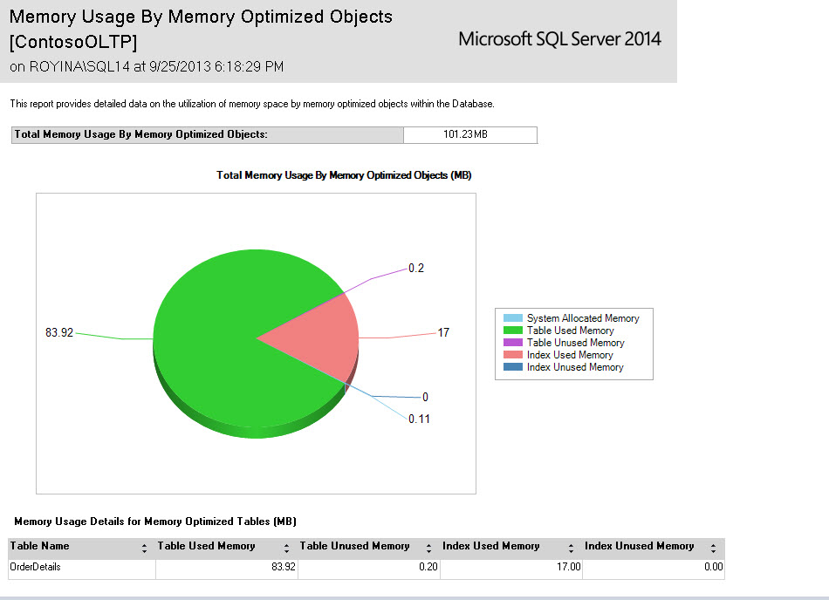

Figure 17 Report of Memory Usage By Memory Optimized Objects

This report shows you the space used by the table rows and the indexes, as well as the small amount of space used by the system. Remember that hash indexes will have memory allocated for the declared number of buckets as soon as they’re created, so this report will show memory usage for those indexes before any rows are inserted. For nonclustered indexes, memory will not be allocated until rows are added, and the memory requirement will depend on the size of the index keys and the number of rows.

## Memory Requirements

When running In-Memory OLTP, SQL Server will need to be configured with sufficient memory to hold all your memory-optimized tables. Failure to allocate sufficient memory will cause transactions to fail at run-time during any operations that require additional memory. Normally this would happen during INSERT or UPDATE operations, but could also happen for DELETE operations on a memory-optimized nonclustered index. As we saw in the section above, a DELETE can cause a page merge to happen, and because index pages are never updated, the merging operation allocates new pages. The In-Memory OLTP memory manager is fully integrated with the SQL Server memory manger and can react to memory pressure when possible by becoming more aggressive in cleaning up old row versions.

When predicting the amount of memory you’ll need for your memory-optimized tables, a rule of thumb is that you should have two times the amount of memory that your data will take up. Beyond this, the total memory requirement depends on your workload; if there are a lot of data modifications due to OLTP operations, you’ll need more memory for the row versions. If you’re doing lots of reading of existing data, there might be less memory required.

For planning space requirements for indexes, hash indexes are straightforward. Each bucket requires 8 bytes, so you can just compute the number of buckets times 8 bytes. The size for your memory-optimized nonclustered indexes depends on both the size of the index key and the number of rows in the table. You can assume each index row is 8 bytes plus the size of the index key (assume K bytes), so the maximum number of rows that fit on a page would be 8176/(K+8). Divide that result into the expected number of rows to get an initial estimate. Remember that not all index pages are 8K, and not all pages are completely full. As pages need to be split and merged, new pages are created and you’ll need to allow space for them, until the garbage collection process removes them.

### Managing Memory with the Resource Governor

A tool that allows you to be proactive in managing memory is the SQL Server Resource Governor. Starting with CTP2, a database can be *bound* to a resource pool and you can assign a certain amount of memory to this pool. The memory-optimized tables in that database cannot use more memory than that. There is a hard limit of 80% that can be assigned to ensure system remains stable under memory pressure. In fact, any memory consumed by memory-optimized tables and their indexes is managed by the Resource Governor, and no other class of memory is managed by the Resource Governor. If a database is not explicitly mapped to a pool, it will implicitly be mapped to the Default pool.

For more information about SQL Server Resource Governor, please see the extensive whitepaper written for the Resource Governor when introduced in SQL Server 2008: <http://view.officeapps.live.com/op/view.aspx?src=http%3A%2F%2Fdownload.microsoft.com%2Fdownload%2FD%2FB%2FD%2FDBDE7972-1EB9-470A-BA18-58849DB3EB3B%2FResourceGov.docx>

Changes in the Resource Governor for SQL Server 2012 can be read about here: <http://msdn.microsoft.com/en-us/library/jj573256.aspx>

The first step is to create a memory pool for your In-Memory OLTP database specifying a MAX_MEMORY_PERCENT value. This specifies the percentage of the SQL Server memory which may be allocated to memory-optimized tables in databases associated with this pool.

For example:

CREATE RESOURCE POOL HkPool WITH (MAX_MEMORY_PERCENT=50);

ALTER RESOURCE GOVERNOR RECONFIGURE;

Once you have created your resource pool(s), you need to bind the databases which you want to manage to the respective pools using the procedure *sp_xtp_bind_db_resource_pool*. Note that one pool may contain many databases, but a database is only associated with one pool at any point in time.

Here is an example:

EXEC sp_xtp_bind_db_resource_pool 'HkDB', 'HkPool';

Because memory is assigned to a resource pool as it is allocated, simply associating a database with a pool will not transfer the assignment of any memory already allocated. In order to do that, you need to take the database offline and bring it back online. As the data is read into the memory-optimized tables, the memory is associated with the new pool.

For example:

ALTER DATABASE [HkDb] SET OFFLINE;

ALTER DATABASE [HkDb] SET ONLINE;

Should you wish to remove the binding between a database and a pool, you can use the procedure *sp_xtp_unbind_db_resource_pool.*  For example, you may wish to move the database to a different pool, or to delete the pool entirely, to replace it with some other pool(s).

EXEC sp_xtp_unbind_db_resource_pool 'HkPool';

# Using the Analyze, Migrate and Report Toolset to Help with Migration

After installing SQL Server 2014 (as long as you have selected to install the complete set of Management Tools) , the Analyze, Migrate and Report toolset can be used to provide recommendations as to what tables and procedures you might want to consider migrating to In-Memory OLTP.

The Analyze and Report aspects of the toolset use a set of new data collectors in conjunction with Management Data Warehouse to capture workload bottleneck and performance metrics. This data can be used to produce reports, available when right-clicking on the MDW database and choosing Reports | Management Data Warehouse. You will then have the option to choose “Transaction Performance Analysis Overview”.

One of the reports will contain recommendations on which tables might provide the biggest performance gain if converted to memory-optimized tables. The report will also describe how much effort would be required to perform the conversion, based on how many unsupported features the table concurrently uses. Another report will contain recommendations on which procedures might benefit from being converted to natively compiled procedures for use with memory-optimized tables.

Once the key tables are identified, the Memory Optimization Advisor included in the Migrate aspect of the Toolset can help you migrate them. Right-clicking on a disk-based table brings up a context menu in which you may click “Memory Optimization Advisor”. The advisor will identify incompatibilities existing within the objects, produce reports which outline these incompatibilities, and also perform a guided migration on a limited set of tables.

The fact that memory-optimized tables can be accessed with interpreted Transact-SQL as well as with natively compiled stored procedures, and that memory-optimized tables can be used in the same queries as disk-based tables means that migrating to an In-Memory OLTP environment can be done gradually and iteratively. Based on recommendations from the Management Data Warehouse reports, you can start converting tables to be memory-optimized tables, one at a time, starting with ones that would benefit most from the memory optimized structures. As you start seeing the benefit of the conversion to memory-optimized tables, you can continue to convert more of more of your tables, but access them using your normal Transact-SQL interface, with very few, if any, application changes.

Once your tables have been converted, you can then start planning a rewrite of the code into natively compiled stored procedures, again starting with the ones that the Management Data Warehouse reports indicate would provide the most benefit. Leveraging the Native Compilation Advisor (another tool, this one located by right clicking stored procedures in Management Studio) to identify incompatibilities in Transact-SQL, can help with migrating these objects.

# Summary

SQL Server In-Memory OLTP provides the ability to create and work with tables that are memory-optimized and extremely efficient to manage, providing performance optimization for OLTP workloads. They are accessed with true multi-version optimistic concurrency control requiring no locks or latches during processing. All In-Memory OLTP memory-optimized tables must have at least one index, and all access is via indexes. In-Memory OLTP memory-optimized tables can be referenced in the same transactions as disk-based tables, with only a few restrictions. Natively compiled stored procedures are the fastest way to access your memory-optimized tables and performance business logic computations.

# For more information:

<http://www.microsoft.com/sqlserver/>: SQL Server Web site

<http://technet.microsoft.com/en-us/sqlserver/>: SQL Server TechCenter

<http://msdn.microsoft.com/en-us/sqlserver/>: SQL Server DevCenter

Did this paper help you? Please give us your feedback. Tell us on a scale of 1 (poor) to 5 (excellent), how would you rate this paper and why have you given it this rating? For example:

* Are you rating it high due to having good examples, excellent screen shots, clear writing, or another reason?
* Are you rating it low due to poor examples, fuzzy screen shots, or unclear writing?

This feedback will help us improve the quality of whitepapers we release.

This whitepaper will eventually be turned into a book on In-Memory OLTP for the final product release. The book will contain more technical details on the following topics;

1. Monitoring and Troubleshooting
2. Data Validation
3. Best Practices Suggestions

If you have specific questions in these areas, or any of the areas discussed in the current paper, that you would like to see addressed in the book, please submit them through the feedback link.

[Send feedback](mailto:hkwb@sqlserverinternals.com?subject=White%20Paper%20Feedback:Hekaton%20Internals).